

PiaoConnect
An Integrated Web-Based Membership, Attendance, Event, and Resource Management System for Barangay Piao

A Capstone Project
Presented to the Faculty of the
College of Computer Studies
DMC College Foundation, Inc.

In partial fulfillment of the
Requirements for the Degree of
Bachelor of Science in Information Technology

ALISWAG, ZEIN BERNARD A.
GODITO, LITO ARTHON R.
MARABULAS, LYKA MAE A.

Mrs. Maria Dara C. Saquin-Woo
Capstone Adviser

CHAPTER I
THE PROBLEM AND ITS BACKGROUND

Introduction
The rapid advancement of information technology has transformed the way organizations manage information and deliver public services. Government institutions increasingly adopt digital systems to improve operational efficiency, data accuracy, transparency, and service delivery, and at the local government level this transformation enables faster processing of records, better information management, and more efficient communication with the public. Bringula et al. [1] emphasized that community-level e-government systems improve the delivery of barangay services by providing web-based platforms for record management, announcements, and other public services, while Aliling et al. [2] found that digitalizing barangay administrative processes through an electronic information management system enhanced the efficiency, accessibility, and reliability of government services.
Barangays play a vital role in delivering basic government services and maintaining records of residents and community activities. One of their regular responsibilities is monitoring attendance during assemblies, meetings, seminars, and other barangay events, yet in many barangays this is still done manually using attendance sheets and logbooks. Manual record-keeping makes information retrieval time-consuming and increases the likelihood of misplaced records, duplicate entries, and human error, ultimately reducing the efficiency of administrative work and delaying service delivery. Agripa and Astillero [3] found that QR code-based attendance systems improve the accuracy, speed, and reliability of attendance recording by automating registration and reducing human error, suggesting that a digital attendance management system could help barangays streamline operations and maintain more accurate records.
This is consistent with the broader body of research on digital attendance and record management reviewed in this study: systems that replace manual, paper-based recording with QR-code scanning and centralized databases reduce duplication of records, speed up registration, and lower the likelihood of human error, while automated reporting and role-based access controls further improve the efficiency and security of record management.
Despite these advancements, Barangay Piao, Roxas, Zamboanga del Norte, still manages attendance and membership records manually using paper forms and folders. Searching for resident information requires checking physical records, making the process slow and prone to error, and during barangay events, residents manually sign attendance sheets, resulting in long queues and delayed registration. These persistent challenges highlight the need for a computerized system that can improve record management, reduce manual work, and provide faster access to information.
Therefore, this study proposes the development of PiaoConnect: An Integrated Web-Based Membership, Attendance, Event, and Resource Management System for Barangay Piao. The proposed system will utilize QR code technology and a centralized database to automate attendance recording, manage memberships, post events, send notifications, generate printable reports, and provide secure and organized digital records for barangay staff and residents.

Statement of the Problem
This study aims to address the problems encountered in the manual attendance and membership management process of Barangay Piao, Roxas, Zamboanga del Norte.
Specifically, this study seeks to answer the following questions:
- What are the problems encountered in the existing manual attendance and membership management process in Barangay Piao?
- What features should the proposed Membership, Attendance, Event, and Resource Management System include to address the identified problems?
- How can the proposed system improve the management of attendance, membership records, event announcements, and notifications?
- What is the level of acceptability of the developed system in terms of:
4.1 Functionality
4.2 Usability
4.3 Reliability
4.4 Security
4.5 Efficiency

Objectives of the Study
The general objective of this study is to design and develop PiaoConnect: Membership, Attendance, Event, and Resource Management System for Barangay Piao, Roxas, Zamboanga del Norte.
Specifically, this study aims to:
- Determine the problems encountered in the current manual attendance and membership management process.
- Design the system based on the identified requirements of the barangay.
- Develop a membership attendance management system with:
3.1 QR code generation
3.2 QR code attendance scanning
3.3 Resident management
3.4 Membership management
3.5 Event posting
3.6 Notification management
3.7 Attendance monitoring
3.8 Printable reports
3.9 Event budget tracking
3.10 Multi-language interface (Filipino/Tagalog and Bisaya)
3.11 Automated post-event feedback collection
3.12 Barangay inventory management
3.13 Household management
3.14 Configurable membership eligibility criteria (age bracket, civil status, and current status)
3.15 Archive and restore (soft-delete) of records
3.16 Borrowed inventory release and return, with undo
3.17 Facebook Page integration for public event posting
3.18 Staff activity log (audit trail)
3.19 SMS notification to residents (and household heads) through an SMS gateway, with a delivery log
3.20 Strong-password policy and self-service password change
- Evaluate the developed system in terms of:
4.1 Functionality
4.2 Usability
4.3 Reliability
4.4 Security
4.5 Efficiency

Scope and Delimitation
This study covers the design, development, implementation, and evaluation of PiaoConnect: Membership, Attendance, Event, and Resource Management System for Barangay Piao, Roxas, Zamboanga del Norte. The system provides a centralized database that enables barangay staff to store, access, and update resident information efficiently. It includes features such as resident management, membership management, QR code generation for members, QR code attendance scanning, event posting, notification management through in-app messages and SMS, attendance monitoring, printable reports, event budget tracking with receipt attachments, automated post-event feedback collection, barangay inventory management with photo records, a multi-language interface (Filipino/Tagalog and Bisaya), and a search function for faster record retrieval, household management, configurable membership eligibility criteria, archive and restore of records, release and return of borrowed inventory with photo evidence and undo, a staff activity log, Facebook Page integration for public event posting, and a strong-password policy with self-service password change.
The system is designed for two types of users: barangay staff and barangay residents. Barangay staff can manage resident information, households, memberships, membership eligibility settings, attendance records, events, notifications, event budgets and expense receipts, barangay inventory including the release and return of borrowed items with photo evidence, archived records, the staff activity log, and the barangay's Facebook Page and SMS integrations, and generate printable attendance and membership reports, while barangay residents can access their profiles, view their memberships, monitor their attendance records, receive notifications, submit feedback after each event, and use their assigned QR codes during barangay events. Residents and staff may also change their own passwords and switch the system's interface between Filipino/Tagalog, Bisaya, and English.
The study focuses on evaluating the effectiveness and acceptability of the system in improving attendance and membership management in Barangay Piao.
The study is limited to the operational needs of Barangay Piao and is intended primarily for membership, attendance, and event management, extended to include event-level budget tracking and a barangay asset inventory. It does not include full financial accounting, payroll processing, procurement, or other administrative services unrelated to membership, attendance, and event management.
All five increments of the prototyping schedule in Table 2 have been designed, built, and demonstrated as working prototypes: resident and membership management, QR code attendance, event and notification management, event budget, inventory, and feedback, and reporting and language support, together with the later refinements recorded in the use cases of this chapter (SMS notification, Facebook Page integration, the release-and-return workflow with undo, household management, the archive, the activity log, and the strong-password policy). Formal testing and the user acceptance evaluation with Barangay Piao staff and resident volunteers are targeted for completion in Capstone 2.
Furthermore, the findings of the study are based on the evaluation conducted in Barangay Piao and may not be applicable to other barangays with different organizational structures, larger populations, or different record management practices.

Significance of the Study
The results of this study will benefit the following:
Barangay Staff. The proposed system will help barangay staff manage resident information, households, memberships, membership eligibility settings, attendance records, events, event budgets, barangay inventory (including the release and return of borrowed items), and in-app and SMS notifications more efficiently. It will reduce the time required for manual recording, minimize errors in record management, improve data retrieval, provide clearer visibility into event expenses and barangay assets, and simplify the generation of attendance and membership reports.
Barangay Residents. The system will provide residents with a more convenient and efficient way of participating in barangay activities. Residents will be able to access their membership information, view attendance records, receive event announcements and notifications, submit feedback after attending an event, and use QR codes for faster attendance registration during barangay events, all through an interface available in Filipino/Tagalog, Bisaya, or English.
Barangay Piao. The implementation of the system will contribute to the modernization of barangay operations by improving the accuracy, organization, and security of attendance and membership records, and by giving officials clearer visibility into event budgets, barangay assets, and resident feedback, a complete staff activity log for accountability, and a public presence on the barangay's Facebook Page. It will support better record management, enhance communication between barangay staff and residents in the language they are most comfortable with, and promote more efficient delivery of community services.
Future Researchers. This study may serve as a reference for future researchers who plan to develop, enhance, or evaluate attendance management systems, membership management systems, or other community-based information systems. It may also provide useful insights into the application of QR code technology and web-based systems in local government units and community organizations.

Definition of Terms
Activity Log. A staff-only, chronological audit trail of significant actions taken in the system, such as creating, archiving, or restoring a record, or releasing borrowed inventory, recorded together with the staff member who performed it.
Archive and Restore. The system's soft-delete mechanism, which removes a record from active lists without permanently deleting it, allowing barangay staff to bring it back later or, if no longer needed, delete it permanently.
Attendance Monitoring. The process of recording and tracking members' participation in barangay events using QR code scanning.
Automated Feedback. A short survey automatically sent to a resident after an event they attended, used to collect ratings and comments for barangay staff to review.
Barangay Inventory. The system's record of barangay-owned assets, supplies, and equipment, including their quantity, condition, and location.
Borrowed Item Release. The recording of barangay equipment being returned to inventory after being borrowed for an event, in the quantity actually returned, with the ability to undo a release recorded in error.
Centralized Database. The digital storage where resident information, attendance records, memberships, and events are securely stored.
Eligibility Criteria. The staff-configurable age bracket, civil status, and current status values used to automatically determine which residents qualify for a given membership group.
Event Budget Tracking. The recording and monitoring of the approved budget and actual expenses of a barangay event within the system.
Facebook Page Integration. The system's connection to the barangay's official Facebook Page, allowing a posted event to also be published there automatically.
Household. A group of residents who share a common address, represented in the system as a single unit with one member optionally designated as household head.
Member. A registered resident of Barangay Piao who has an account in the system and belongs to one or more barangay memberships.
Membership, Attendance, Event, and Resource Management System. The computerized system developed in this study for managing resident memberships, attendance records, events, notifications, event budgets, and barangay inventory in Barangay Piao.
Multi-language Support. The system's ability to display its interface in Filipino/Tagalog, Bisaya, or English, based on the user's preference.
QR Code. A machine-readable code generated by the system that contains a member's identification information for attendance scanning.
SMS Gateway. The third-party text-messaging service (IPROG SMS) through which the system sends event and system notifications to residents’ mobile numbers and, where recorded, to the household head. Every attempt is stored in an SMS log with its delivery status (sent, failed, or simulated when no gateway is configured).
Staff. Authorized barangay personnel responsible for managing resident records, memberships, events, notifications, and attendance.
Strong Password. A password that is 8 to 64 characters long, contains uppercase and lowercase letters, a digit, and a special character, and contains no spaces, enforced by the system whenever a password is created or changed.

CHAPTER II
REVIEW OF RELATED LITERATURE AND STUDIES

This chapter provides a review of the relevant literature and existing systems that help the development of PiaoConnect: Membership, Attendance, Event, and Resource Management System for Barangay Piao, Roxas, Zamboanga del Norte. The chapter shows what is known about digital attendance and documentation practices, what solutions have been implemented for similar challenges in other contexts, and what limitations in today's solutions hinder the creation of a solution with the particular set of functionalities that PiaoConnect aims to provide. All cited sources in this review were retrieved from peer-reviewed journals, refereed conference papers, or peer-reviewed multidisciplinary journals written during the period from 2021 to 2026, unless stated otherwise.

Related Literature
The current literature on QR codes states their effectiveness as alternatives to manual and paper-based systems for attendance tracking. In a 2023 study by Raut et al. [4], an automated attendance tracking system using QR codes was developed, highlighting the automatic recording of attendance through databases and the elimination of the high cost of biometric devices.
In a related study, Pati et al. [5] presented an innovative QR code-based attendance system that reduces time and reduces errors in recording attendance compared to traditional handwritten logs. Chowdhury [6], in similarity, also used QR codes in conjunction with biometric identification and global positioning system (GPS) tracking, which indicates that using only one method of verification would not be sufficient for proving the identity and presence of an individual. These two studies are further evidence supporting that QR code identification systems have transitioned into efficient, inexpensive, and accurate means of recording attendance. This is why, as its first theme, PiaoConnect takes advantage of QR code generation and scanning for tracking attendance at barangay events.
Secondly, PiaoConnect concerns the digitization of community and resident records at the barangay level. A study conducted by Melendres and Aranda [7] developed and evaluated a web-based management system for resident information, which allowed barangay personnel and residents to access records through accounts secured by QR codes and mobile PINs — the system was found to meet user requirements across six ISO/IEC 25010 quality criteria. Further, another study likewise developed a web-based profiling and issuance system to centralize resident data of a barangay and streamline the issuance of certificates, all together evaluated across functional suitability, usability, reliability, and security [8]. Most recently, a web-based portal named BarangayConnect was introduced by Enaño et al. [9], centralizing resident records and document requests.
These studies show that Philippine barangays have increasingly adopted centralized, web-based databases to replace manual logbooks — the same problem this study identifies at Barangay Piao — but their scope is consistently limited to resident profiling and document issuance rather than the tracking of membership or event attendance, which is the specific gap PiaoConnect is designed to close.
A third theme in the literature concerns timely communication between an organization and its members. An event management system that features SMS notification for the Mindanao People's Care Foundation, Inc. has been designed in accordance with a study by Reyes et al. [10] that found that automated SMS alerts speed up the transmission of meeting and event information compared to manual, verbal, or paper-based announcements. The respondents rated the system favorably in terms of function, reliability, and security. This finding supports the inclusion of an integrated event-posting and notification module in PiaoConnect, so that barangay staff can announce assemblies and activities and have residents automatically informed, rather than relying on verbal announcements or posted notices that residents may miss.
A fourth theme, added in this revision of the study, concerns language accessibility in Philippine e-government platforms. Concepcion [11] examined language choice across 235 Philippine government websites and found that English is used almost exclusively across national, local, and government-corporation websites, with Filipino and regional languages such as Bisaya appearing only minimally, mostly in informal or cultural content rather than in service transactions. The study argues for a tripartite multilingual approach — English, Filipino, and the relevant regional lingua franca — so that government platforms are equally accessible to residents regardless of which language they are most comfortable in. This finding directly supports PiaoConnect's inclusion of a Filipino/Tagalog and Bisaya interface option alongside English, since Barangay Piao residents who are more comfortable in Bisaya should not be placed at a disadvantage when using a government system that manages their membership and attendance records.
A fifth theme concerns structured feedback and project evaluation as part of barangay and youth-council digital systems. Anggoto et al. [12] developed Kabataan-Konek, a web-based youth information management system for a Sangguniang Kabataan council, which incorporated surveys to support project monitoring and evaluation alongside QR-based clearance issuance, and was rated highly against the ISO/IEC 25010 quality model. This supports the inclusion of an automated feedback module in PiaoConnect, so that barangay staff can systematically gather residents' assessment of each event rather than relying on informal, undocumented comments.
It should be noted, however, that within the 2021–2026 window used for this review, the researchers were not able to locate a peer-reviewed study that specifically evaluates event-level budget tracking or barangay asset inventory as a feature of a community information system; most available material on these two topics consists of local government financial forms, vendor product pages, or non-peer-reviewed capstone repositories, which do not meet this study's inclusion criteria. The inclusion of event budget tracking and barangay inventory management in PiaoConnect is therefore justified primarily by the operational gap observed directly in Barangay Piao — where event expenses and barangay-owned equipment are currently tracked, if at all, on paper — rather than by a specific literature precedent. The researchers recommend that this gap be revisited with the capstone adviser as the study progresses, in case a more specialized public-finance or asset-management source becomes available.

Related Systems
Alongside the literature, several existing systems were examined to understand current solutions and their limitations, keeping the review factual and confined to what each system was reported to do.
QR code-based attendance systems, such as the one developed by Raut et al. [4] and the smart tracking system of Pati et al. [5], are inexpensive to deploy and eliminate the need for biometric scanners, and they reliably automate the recording of attendance. However, these systems were designed for classroom or institutional settings; they generate and scan QR codes purely for attendance and do not manage broader concerns such as resident profiles, membership records, or event notifications, which a community-based system like PiaoConnect must also handle.
The Web-Based Resident Information Management System of Melendres and Aranda [7] and the Web-Based Barangay Profiling and Issuance System of Ballaran et al. [8] are both well-suited to organizing resident information and issuing barangay documents, and both were positively evaluated for usability and security. Their limitation, from the perspective of this study, is that neither system was built to monitor attendance at assemblies or events, nor to track which residents belong to which barangay membership group — both systems focus on profiling and document issuance rather than participation tracking.
BarangayConnect [9] is the most recent of the previously reviewed systems and centralizes resident data while automating certificate and clearance requests, additionally applying predictive analytics for demographic forecasting. It is comprehensive for administrative document processing, but like the systems above, it does not include a QR-based attendance mechanism, a membership module, or an event-notification feature.
The Event Management System with SMS Notification developed for the Mindanao People's Care Foundation, Inc. [10] is effective at rapidly disseminating event announcements to members through SMS, which does not require an internet connection. Its scope, however, is limited to notification; it does not maintain resident or membership records, nor does it track attendance, so it functions only as one piece of the puzzle that PiaoConnect intends to integrate into a single platform.
Kabataan-Konek [12], reviewed here as the most recently published system, is a web-based youth information management system built for a barangay's Sangguniang Kabataan council. It generates QR codes for youth-clearance authenticity, maintains a resident-style profile module, and — notably — includes survey tools for project monitoring and evaluation, giving it the one feature-level precedent this study found for an automated feedback mechanism. However, its QR code use is limited to clearance verification rather than event attendance scanning, it has no membership-group or event-posting module, and it does not track budgets or barangay assets, so it addresses a related but narrower problem than the one PiaoConnect is designed to solve.
Across the systems reviewed, none combine QR-based attendance monitoring, membership tracking, event posting with budget tracking, notification management, structured post-event feedback, a multilingual interface, and barangay inventory into a single platform. This gap, together with the four features added to this study, is summarized in Table 1.

Conceptual Framework
The study is guided by the Input–Process–Output (IPO) model, which frames the system as the transformation of defined inputs into a desired output through a structured development process.
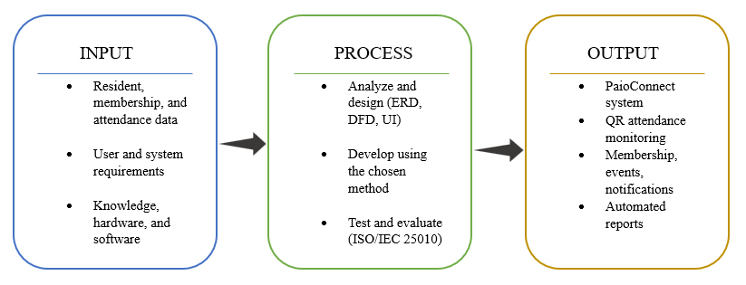

Figure 1. The Input-Process-Output (IPO) framework of the study
Input. The resources and information the study requires: resident, membership, attendance, event-budget, and barangay-inventory data; the functional and non-functional requirements gathered from Barangay Piao staff and residents, including their preferred interface language; and the knowledge, hardware, and software needed to build the system.
Process. The development activities: analyzing and designing the system — including the entity-relationship diagram, data flow diagrams, and interface designs for QR code generation, QR code scanning, resident management, membership management, event posting, event budget tracking, notification management, automated post-event feedback collection, barangay inventory management, and the Filipino/Tagalog–Bisaya–English interface — developing the system using the chosen methodology, and testing and evaluating it against the ISO/IEC 25010 quality characteristics of functionality, usability, reliability, security, and efficiency.
Output. The resulting PiaoConnect: Membership, Attendance, Event, and Resource Management System, a centralized, multilingual platform that automates attendance monitoring, membership tracking, event announcements and budgets, resident feedback collection, barangay inventory records, and report generation for Barangay Piao, Roxas, Zamboanga del Norte.
A feedback loop connects the output back to the process: results from testing and user acceptance evaluation are used to refine the system, consistent with the study's iterative development approach.

Synthesis of the Reviewed Literature and Systems
Across the reviewed literature and systems, a consistent pattern emerges: QR code technology is a proven, low-cost way to automate attendance; centralized, web-based databases have already replaced manual logbooks for barangay resident profiling and document issuance in several Philippine barangays; automated notification measurably improves how quickly members receive event information; multilingual access is a documented, unresolved gap in Philippine e-government platforms; and structured feedback surveys are beginning to appear in newer barangay and youth-council systems as a way to support project evaluation.
Yet no single reviewed system combines QR-based attendance monitoring with resident management, membership tracking, event posting, event budget tracking, notification management, automated post-event feedback, a multilingual interface, barangay inventory management, and printable reporting in one platform built specifically for barangay-level membership and assembly monitoring. This gap is summarized in Table 1.
Table 1 Comparative Matrix of the Reviewed Systems and PiaoConnect's Features
System | QCG | QCAS | RM | MM | EP | NM | AM | PR | ML | FB | BT | INV
QR Code-Based Attendance System for education settings [4] | ✓ | ✓ | ✗ | ✗ | ✗ | ✗ | ✓ | ✓ | ✗ | ✗ | ✗ | ✗
Web-Based Resident Information Management System [7] | ✓ | ✗ | ✓ | ✗ | ✗ | ✓ | ✗ | ✓ | ✗ | ✗ | ✗ | ✗
Web-Based Barangay Profiling and Issuance System [8] | ✗ | ✗ | ✓ | ✗ | ✗ | ✗ | ✗ | ✓ | ✗ | ✗ | ✗ | ✗
BarangayConnect Web-Based Information Portal [9] | ✗ | ✗ | ✓ | ✗ | ✗ | ✗ | ✗ | ✓ | ✗ | ✗ | ✗ | ✗
Event Management System with SMS Notification [10] | ✗ | ✗ | ✗ | ✗ | ✓ | ✓ | ✗ | ✗ | ✗ | ✗ | ✗ | ✗
Kabataan-Konek: Barangay Web-Based Youth Info. System [12] | ✓ | ✗ | ✓ | ✗ | ✗ | ✗ | ✗ | ✓ | ✗ | ✓ | ✗ | ✗
PiaoConnect (Proposed System) | ✓ | ✓ | ✓ | ✓ | ✓ | ✓ | ✓ | ✓ | ✓ | ✓ | ✓ | ✓

Legend:
✓ feature present in the reviewed system;
✗ feature absent (gap addressed by PiaoConnect).
Acronyms:
QCG → QR Code Generation
QCAS → QR Code Attendance Scanning
RM → Resident Management
MM → Membership Management
EP → Event Posting
NM → Notification Management
AM → Attendance Monitoring
PR → Printable Reports
ML → Multi-language Interface
FB → Automated Feedback
BT → Event Budget Tracking
INV → Barangay Inventory Management
As Table 1 shows, each existing system addresses only part of the problem: QR-based attendance systems handle scanning but not resident or membership data; barangay resident and profiling systems handle records but not attendance or events; the SMS-based event system handles notification but nothing else; and the most recent youth-council system adds structured feedback but not event-level attendance, budgeting, or a multilingual interface. PiaoConnect is positioned to fill this gap by combining QR code generation, QR code attendance scanning, resident management, membership management, event posting, event budget tracking, notification management, attendance monitoring, automated post-event feedback, a multilingual interface, barangay inventory management, and printable reports into a single centralized system built for Barangay Piao, Roxas, Zamboanga del Norte.

Annotated Bibliography
The following annotated bibliography lists each literature reviewed in IEEE citation style, together with its currency (years since publication, relative to 2026) and the specific research gap it leaves that PiaoConnect addresses.
[1] R. P. Bringula, M. A. D. Vale, J. A. Napolis, F. P. Oliva, and D. J. T. De La Serna, “E-Barangay: A framework for a web-based system for local communities and its usability,” Procedia Comput. Sci., vol. 197, pp. 573–580, 2022. Currency: 4 years (published 2022). This study proposed a web-based e-governance framework for local communities, evaluated for usability, to support record management and public announcements. Gap: the framework addresses general community record-keeping and usability at a conceptual level; it does not include QR-based attendance monitoring, membership-group tracking, or the event/notification module PiaoConnect implements.
[2] J. T. Aliling, B. B. Santa Ana, and K. T. Soberano, “Digitalizing governance: A transformation on the processes of one community in the Philippines,” Zenodo, 2025. Currency: less than 1 year (published 2025), the most recent source reviewed at the time it was added. This study examined how digitalizing administrative processes improved the efficiency, accessibility, and reliability of services in a Philippine community. Gap: the study evaluates governance digitalization at a general, process-transformation level and does not itself implement or evaluate a QR-based attendance mechanism, membership module, or event-notification feature.
[3] D. J. B. Agripa and S. F. Astillero, “Development of employee attendance and management system using quick response (QR) code in Sorsogon State University,” Eur. J. Educ. Stud., vol. 9, no. 7, pp. 345–361, 2022. Currency: 4 years (published 2022). This study automated employee attendance at a state university using QR code generation and scanning, reporting improved accuracy, speed, and reliability over manual sign-in sheets. Gap: the system is scoped to institutional employee attendance and does not extend to resident profiling, membership tracking, event posting, or notification management — the additional modules PiaoConnect provides for a barangay setting.
[4] S. Raut, P. Bhure, P. Bariye, A. Nandeshwar, and J. Adhikari, “QR code-based attendance system,” Int. Res. J. Modernization Eng. Technol. Sci., vol. 5, no. 6, pp. 425–429, Jun. 2023. Currency: 3 years (published 2023). This study developed a QR code generator, scanner, and database to automate classroom attendance, reporting improved cost, speed, and security over biometric and manual methods. Gap: the system is confined to attendance logging in an educational setting and includes no resident profiling, membership tracking, event posting, or notification features — the components PiaoConnect adds for a barangay context.
[5] S. Pati, S. Bhanja, A. Majumder, S. Sahu, S. Banerjee, and G. Sen, “A novel QR code based smart attendance tracking system,” in Proc. 2023 7th Int. Conf. Electron., Mater. Eng. Nano-Technol. (IEMENTech), 2023. Currency: 3 years (published 2023). This IEEE conference paper presented a QR-based smart attendance tracking mechanism to reduce the time and error associated with manual sign-in sheets. Gap: like similar QR studies, it treats attendance as a standalone function and does not integrate resident or membership records, so it cannot on its own manage a barangay's broader monitoring needs.
[6] F. Y. Chowdhury, “Implementation of attendance management system utilizing fingerprint, QR code, and GPS technology in educational institutions,” Int. J. Sci. Res. (IJSR), vol. 12, no. 9, pp. 2016–2019, 2023. Currency: 3 years (published 2023). This study combined fingerprint, QR code, and GPS verification to strengthen identity and location confirmation during attendance recording. Gap: the multimodal approach adds verification strength but still does not extend to membership management, event posting, or notification, and its added hardware/GPS requirement is heavier than what a barangay-level deployment needs.
[7] U. M. Melendres and K. M. Aranda, “Development and evaluation of a web-based resident information management system,” J. Comput. Softw. Program, vol. 1, no. 1, pp. 14–22, 2024. Currency: 2 years (published 2024). Using the Rapid Application Development model, this study built a resident information system evaluated favorably across six ISO/IEC 25010 criteria (mean ratings 3.42–3.62). Gap: the system centralizes resident profiles and document requests and uses QR codes only for account login, not for attendance; it does not track membership groups, post events, or monitor attendance at barangay activities.
[8] M. J. G. Ballaran, M. J. M. Donaire, R. M. Singzon, S. M. Naz, D. V. Tanael, and C. J. Centeno, “Development and evaluation of web-based barangay profiling and issuance system using regression analysis,” World J. Adv. Res. Rev., vol. 20, no. 3, pp. 060–072, 2023. Currency: 3 years (published 2023). This study centralized resident profiling and automated certificate and permit issuance, evaluated positively across ISO/IEC 25010 sub-characteristics (means of 4.71–4.79). Gap: the system's scope is profiling and document issuance; it does not include attendance monitoring, QR-based scanning, membership management, or event and notification features.
[9] J. V. Enaño, K. P. Natividad, D. R. Pantoja, F. C. D. Ebi, J. V. Bautista, and D. Cura, “BarangayConnect: A web-based information portal for resident data, administrative services, and community records using data analytics and linear regression algorithms,” Int. J. Res. Innov. Soc. Sci., vol. 9, no. 10, pp. 1485–1497, Nov. 2025. Currency: less than 1 year (published November 2025). BarangayConnect centralizes resident data, automates document requests, and uses regression analysis to forecast service demand, with an overall mean acceptability rating of 3.0 (Agree). Gap: despite its recency and predictive analytics component, the system still does not provide QR-based attendance scanning, membership tracking, or event/notification management.
[10] F. M. Reyes, M. A. Abdulgani, M. F. Aliuden, J. M. Mantikayan, T. S. Guiamalon, S. G. Dilna, H. A. Mohamad, and S. Z. D. Nawal, “Event management system with SMS notification for Mindanao People's Care Foundation, Inc.,” Psychol. Educ.: Multidiscip. J., vol. 3, no. 7, pp. 600–609, 2022. Currency: 4 years (published 2022). This system automated the sending of SMS event and meeting announcements to an organization's members, and was rated favorably (grand mean 3.94) for function and reliability, working even without an internet connection. Gap: the system notifies members of events but does not manage resident records, membership status, or attendance, so it cannot verify or monitor who actually attended the events it announces.
[11] G. P. Concepcion, “Language choice in Philippine government websites: Sociolinguistic issues and implications,” SUVANNABHUMI, vol. 13, no. 1, pp. 35–64, Jan. 2021. Currency: 5 years (published 2021). This study analyzed language use across 235 Philippine government websites and found English overwhelmingly dominant, with Filipino and regional languages such as Bisaya minimally used, mostly outside of core service transactions; it proposes a tripartite English-Filipino-regional-language approach to improve accessibility. Gap: the study examines existing government websites rather than proposing or evaluating a specific system; it provides the sociolinguistic rationale for, but not a working precedent of, the multilingual interface PiaoConnect implements.
[12] B. A. Anggoto, C. G. Gonzaga, T. J. S. Varona, and P. C. Encarnacion, “Kabataan-Konek: A barangay web-based youth information management system with data analytics,” Int. J. Sci. Appl. Inf. Technol., vol. 14, no. 3, pp. 27–30, May–Jun. 2025. Currency: less than 1 year (published 2025), the most recent source reviewed. This study developed a web-based youth information system for a Sangguniang Kabataan council that included survey tools for project monitoring and evaluation alongside QR-based clearance issuance, scoring a 95.63% average across ISO/IEC 25010 criteria. Gap: its QR code use is limited to clearance authentication rather than event attendance scanning, and it does not include a membership module, event budgeting, or a multilingual interface; it is, however, the closest precedent found for PiaoConnect's automated feedback module.

CHAPTER III
METHODOLOGY
This chapter presents the methodology used in developing PiaoConnect: An Integrated Web-Based Membership, Attendance, Event, and Resource Management System for Barangay Piao. It describes the overall project design, the development methodology adopted and its justification, the functional and non-functional requirements of the system, the analysis and design models produced during system design, the tools and technologies selected for implementation, and the plan for testing and evaluating the system.

Project Design
This study follows a developmental research design, in which a working information system is designed, constructed, and evaluated as the principal output of the project. Because the objective is to produce a functioning membership and attendance management system for Barangay Piao rather than to test a hypothesis, the methodology places emphasis on iterative design, continuous validation with barangay staff, and structured evaluation against recognized software quality criteria. The sections that follow present the development methodology, the specified requirements, the system design models, the technologies employed, and the testing and evaluation plan.

Development Methodology
PiaoConnect was developed using a prototyping approach within an iterative and incremental model [13]. This methodology was adopted because, at the outset of the study, the barangay staff of Barangay Piao could describe their manual attendance and membership problems clearly but could not fully specify every screen and report they would eventually need; showing them working prototypes of each module allowed their requirements to be progressively clarified and confirmed. Developing the system in small, functionally complete increments — resident and membership management first, followed by QR code attendance, event and notification management, and finally budget tracking, inventory, and feedback — also reduced risk for a small, still-learning student development team, since each increment could be corrected before the next was attempted. A purely sequential Waterfall model was considered but not adopted, since it assumes requirements are stable and complete before design begins and defers client feedback until late in development; this fit poorly with a barangay client that had not previously used a digital system and whose feature priorities were expected to shift once staff could see and use working screens. Figure 1 illustrates the five phases of the adopted methodology and the feedback loop that connects evaluation back into design for each increment.
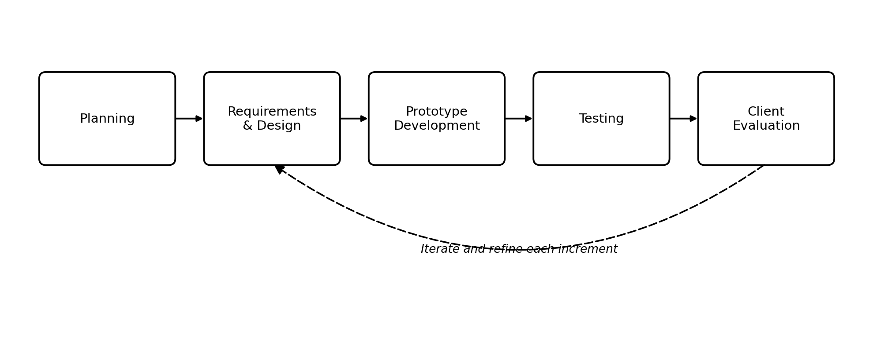
Figure 1. Prototyping approach within the iterative and incremental development model adopted for PiaoConnect.
Planning. The proponents, together with the capstone adviser and Barangay Piao staff, defined the scope of each increment, set a development schedule, and confirmed the priority of features based on the objectives identified in Chapter 1. Table 2 lists the increments in the order they will be built.

Table 2
Development Increments
Increment | Scope
1 | Resident and membership management: resident registration, profile management, membership groups, and account roles
2 | QR code attendance: QR code generation, member QR code display, and staff scanning of attendance at events
3 | Event and notification management: posting events, restricting events to membership groups, and automated in-app notifications
4 | Budget, inventory, and feedback: event budget and expense tracking with receipt attachments, barangay inventory management with item photos, borrowed-item release and return (with undo and photo evidence), and automated post-event feedback
5 | Reporting, language, integration, and security refinements: printable attendance, membership, budget, and inventory reports; multi-language interface support; household management, eligibility settings, archive and restore, and the activity log; SMS and Facebook Page integration; and the strong-password policy

Requirements and Design. For each increment, the team analyzed the affected processes and data, and produced or updated the process models, data model, and interface designs presented later in this chapter before any coding was undertaken.
Prototype Development. A working prototype of the increment — for example, the QR code generation and scanning module — was built and demonstrated to barangay staff and, where applicable, a small group of resident volunteers.
Testing. Each increment was tested against the functional and non-functional requirements it was meant to satisfy, to confirm that it behaved correctly before being shown to the client.
Client Evaluation. Feedback gathered from testing and from barangay staff was used to refine the increment before the next cycle began, as represented by the feedback loop in Figure 1. This cycle will continue through Capstone 2 until all the modules described in Chapter 1 have been implemented and evaluated.

System Requirements
The functional and non-functional requirements of PiaoConnect were derived from interviews with Barangay Piao staff, informal observation of the current manual attendance and membership process, and the objectives and scope established in Chapter 1. The functional requirements specify the tasks the system must perform; the non-functional requirements specify the quality attributes the system must exhibit while performing them. Table 3 presents the core functional requirements, each traceable to a specific objective of the study.
Table 3
Functional Requirements of PiaoConnect
ID | Functional Requirement
FR-1 | The system shall allow barangay staff to register, update, and search resident records.
FR-2 | The system shall allow barangay staff to create membership groups and assign residents to one or more memberships.
FR-3 | The system shall generate a unique QR code for each registered member and let the member display it on their own device.
FR-4 | The system shall allow barangay staff to scan a member's QR code to record attendance at an event.
FR-5 | The system shall allow barangay staff to post events with details such as date, time, location, and description.
FR-6 | The system shall send automated in-app notifications to members regarding posted events, and shall also send an SMS to the member’s mobile number (and to the household head when one is recorded), logging the delivery status of every SMS.
FR-7 | The system shall record and display attendance per member and per event for monitoring purposes.
FR-8 | The system shall allow barangay staff to generate printable attendance and membership reports.
FR-9 | The system shall allow barangay staff to record the approved budget and actual expenses of each event, and shall require a receipt (image or PDF) for every expense recorded.
FR-10 | The system shall allow barangay staff to record and monitor barangay-owned inventory items, including quantity, condition, storage location, and an item photo.
FR-11 | The system shall automatically send a short feedback survey to members after an event they attended.
FR-12 | The system shall allow users to switch the interface language among Filipino/Tagalog, Bisaya, and English.
FR-13 | The system shall require users to log in with valid credentials before accessing staff or member functions, and shall limit repeated login attempts to six per minute.
FR-14 | The system shall allow barangay staff to group resident records into household units, designate a household head, and keep a resident's household link in sync when it changes.
FR-15 | The system shall allow barangay staff to configure the age bracket, civil status, and current status lookup values used to determine membership eligibility.
FR-16 | The system shall allow barangay staff to archive (soft-delete) and restore resident, event, membership, and inventory records, and to permanently delete archived records when needed.
FR-17 | The system shall allow barangay staff to release borrowed inventory items back to stock in partial or full quantities, shall require a photo as evidence of each release, and shall allow a release to be undone, with an evidence photo, if it was recorded in error.
FR-18 | The system shall allow barangay staff to connect the barangay’s Facebook Page so that posted events can also be published publicly through the Facebook Graph API.
FR-19 | The system shall maintain a staff-only activity log recording significant actions taken in the system for accountability and troubleshooting.
FR-20 | The system shall enforce a strong-password policy (8 to 64 characters with uppercase and lowercase letters, a digit, and a special character, and no spaces) whenever a password is created or changed.
FR-21 | The system shall allow a logged-in user to change their own password by entering and confirming a new password.
FR-22 | The system shall validate contact numbers as eleven-digit mobile numbers beginning with 09 before saving a resident or profile record.

The non-functional requirements, summarized in Table 4, define the quality attributes the system must meet. Each is stated in measurable terms so that it can be verified during the evaluation described later in this chapter.
Table 4
Non-Functional Requirements of PiaoConnect
Category | Non-Functional Requirement
Performance | A QR-code attendance scan shall be recorded in under 3 seconds under normal network conditions.
Usability | Barangay staff and residents shall be able to perform common tasks (registration, attendance scanning, event posting) after no more than 30 minutes of orientation.
Reliability | The system shall remain available throughout the scheduled duration of a barangay event, with a target uptime of at least 99 percent.
Security | Access to staff functions shall be role-based and enforced on the server, passwords shall follow the strong-password policy and be stored using industry-standard hashing, login attempts shall be rate-limited, and personal data shall be handled in accordance with the Data Privacy Act of 2012 [15].
Efficiency/Scalability | The system shall support at least 5,000 registered residents and at least 300 concurrent attendance scans during peak assembly hours.
Maintainability | Business logic shall be separated from the HTTP layer into services, and third-party integrations (SMS and Facebook) shall fail gracefully so that an outage never blocks posting an event or recording attendance.

System Design
System design translates the requirements in Table 3 and Table 4 into concrete models. Process models describe how data moves between residents, staff, and the system; the data model describes how information about residents, memberships, events, attendance, budgets, and inventory is structured and stored; and the architecture and interface designs describe how the system is organized internally and how it will be operated by its two classes of users.
3.4.1 Process Models
The processes of PiaoConnect were modeled using a context diagram, a level-0 data flow diagram, and a use case diagram, each drawn using a single consistent notation. The context diagram in Figure 2 presents the system as a single process together with the external entities it exchanges data with: the resident/member and the barangay staff, who use the system directly, and two external services at the boundary of the study, the SMS gateway, through which event and system notifications are delivered to mobile phones, and the Facebook Graph API, through which posted events are published to the barangay’s Facebook Page. In-app notifications and post-event feedback prompts continue to be generated entirely within the system.
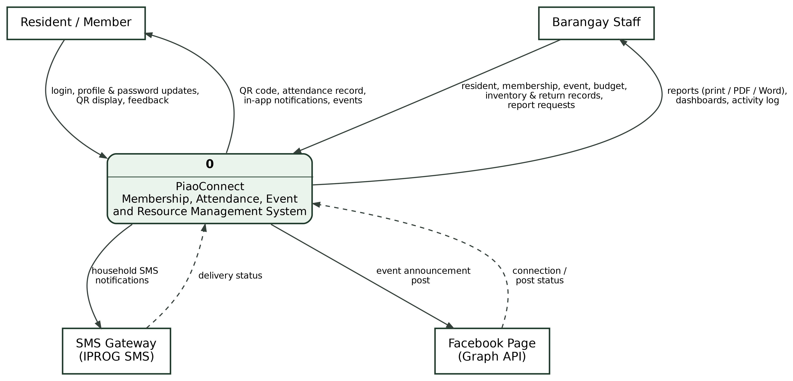
Figure 2. Context diagram of the proposed PiaoConnect system.
The context diagram was decomposed into the level-0 data flow diagram in Figure 3, which details the five major processes of the system — managing resident and membership records (P1), generating and scanning QR codes for attendance (P2), managing and announcing events (P3), managing event budgets and barangay inventory (P4), and generating reports and collecting feedback (P5) — together with the data stores each process reads from or writes to, and the data each process exchanges with the SMS gateway and the Facebook Graph API.
A use case diagram was also prepared to capture the goals of each actor, shown in Figure 4. The Resident/Member can manage their own profile, display their QR code, view their attendance history, receive notifications, submit post-event feedback, and view posted events. The Barangay Staff can manage resident and membership records, generate QR codes, scan attendance, post events and trigger notifications, track event budgets and receipts, manage barangay inventory and the release and return of borrowed items, manage households, configure membership eligibility settings, archive and restore records, view the activity log, manage the barangay’s Facebook Page integration, and generate printable reports. Because both actors can log in (UC-1), log out (UC-18), switch the interface language (UC-17), and change their password (UC-25), these four use cases are attached to a generalized Registered User actor from which the Barangay Staff and Resident/Member actors inherit. Registering a resident (UC-2) and displaying a QR code (UC-12) both include generating the member QR code (UC-5), and the release and return of borrowed items (UC-22) extends barangay inventory management (UC-9), as indicated by the include and extend relationships in Figure 4. The diagram is drawn full-width on its own A4 page so that every use case and its relationships remain legible.

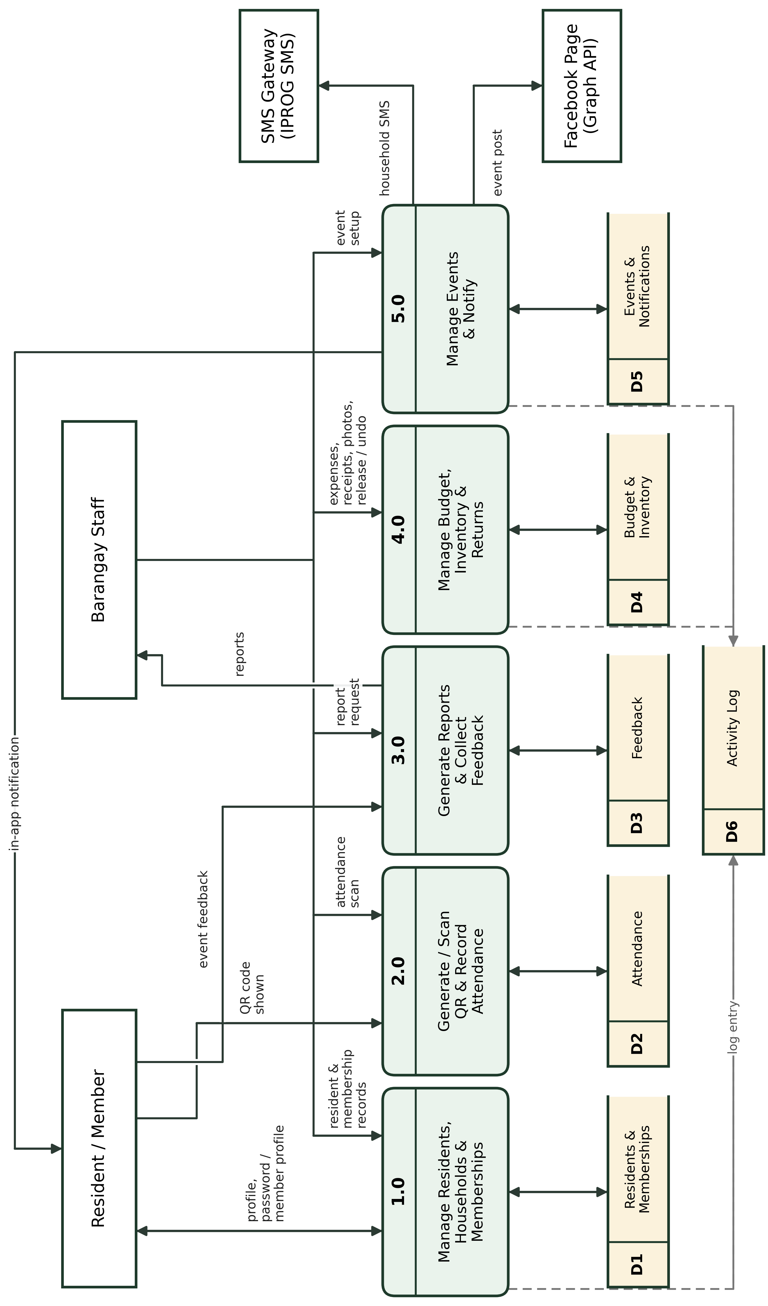
Figure 3. Level-0 data flow diagram of the proposed PiaoConnect system.
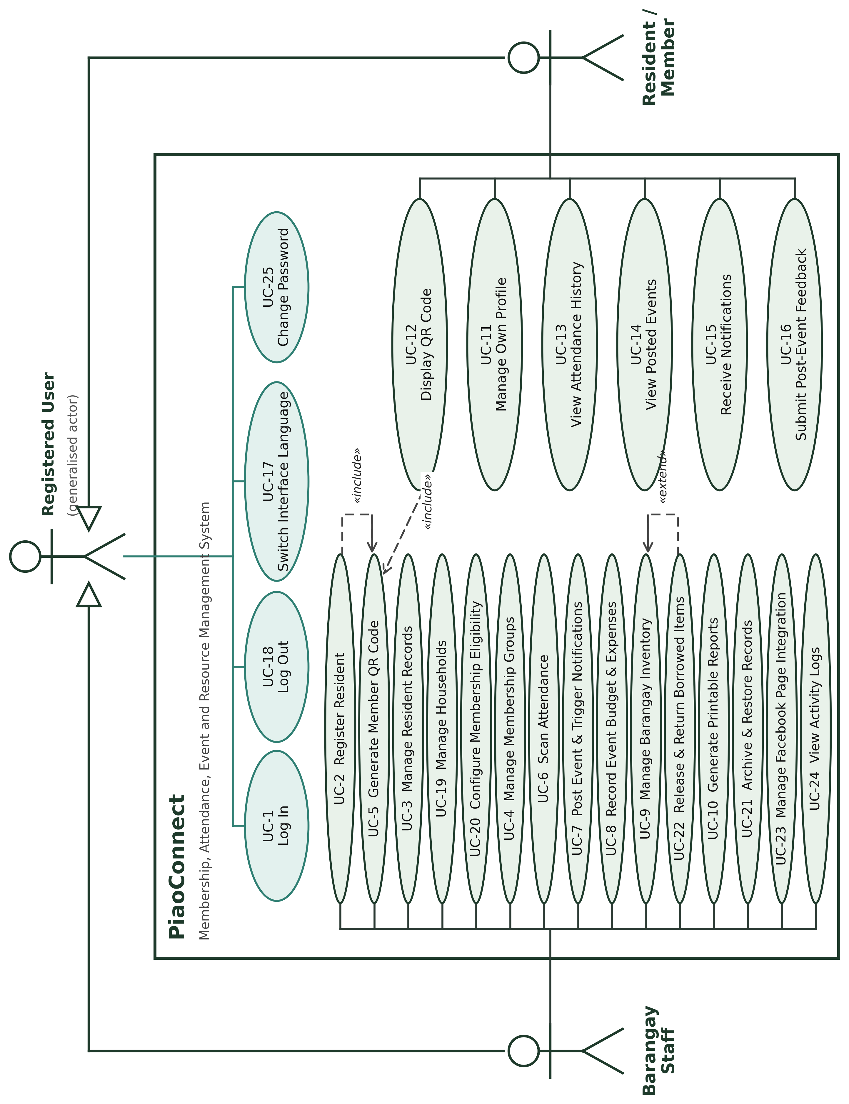
Figure 4. Use case diagram of the proposed PiaoConnect system.
3.4.2 Data Model
The data requirements of PiaoConnect were modeled as an entity-relationship diagram, shown in Figure 5, which is drawn full-width on its own A4 page so that every entity, its attributes, and its relationships are legible; the framework-level tables that Laravel maintains for sessions, caching, and queued jobs are excluded. The central entity is users, which stores every resident and staff account and distinguishes the two through its role field; a resident becomes a system user directly, with household_id linking related residents through the households entity. A user may belong to one or more membership groups; this many-to-many relationship between users and memberships is resolved through the membership_residents junction entity, and a membership can be deactivated (is_active, deactivated_at, and deactivated_reason) without deleting it. Membership eligibility rules reference three lookup entities, age_brackets, civil_statuses, and current_statuses, the last of which also participates in a many-to-many relationship with users through the current_status_user junction entity, recording a user’s status history over time. The many-to-many relationship between users and events, expressed through participation in barangay activities, is resolved through the attendances junction entity, which records the time-in, time-out, and status of each scan. feedback and event_expenses are likewise modeled as dependent entities of events, capturing post-event ratings and comments and itemized expenses with their receipt files respectively, while event_inventory_items resolves the many-to-many relationship between events and inventory_items for equipment borrowed per event. event_inventory_releases records each subsequent return of those borrowed items back to stock, together with its evidence photo, and depends on both events and inventory_items; event_inventory_release_undos, new in this revision, records each correction of a release, with the quantity undone, who undid it, and its own photo, so that a release can be partially or fully undone more than once. notifications and sms_logs each depend on users and, optionally, on events. activity_logs records a textual, staff-readable audit trail keyed by user_code but is not enforced by a foreign key, and integration_settings is a standalone configuration entity holding the Facebook and SMS settings with no relationship to the rest of the schema. Every entity has a designated primary key, and the model is normalized to the third normal form. Table 5 lists the entities and what each holds.
Table 5
Entities of the Data Model
Entity | Purpose
users | Every resident and barangay-staff account. A single table distinguished by its role field (Staff or Resident), linked to households and to civil_statuses, flagged has_account to mark whether the person can log in, and holding the contact number, preferred language, and household-head flag.
households | A household unit at a shared address, referenced by member users through household_id; supports grouping residents who live together.
civil_statuses | Lookup table of civil-status labels (e.g., Single, Married), referenced by users and by membership eligibility rules.
age_brackets | Lookup table of age ranges used to define which users are eligible for a given membership.
current_statuses | Lookup table of status labels (e.g., active, relocated) a user can hold over time, tracked historically through current_status_user.
current_status_user | Junction entity resolving the many-to-many relationship between users and current_statuses, recording each status a user has held.
memberships | A defined membership group (for example, a Purok organization or the senior citizens’ association) with optional eligibility rules based on age bracket, civil status, current status, and gender, and an active flag with the date and reason it was deactivated.
membership_residents | Junction entity resolving the many-to-many relationship between users and memberships.
events | A barangay activity, holding its schedule, call times, location, description, approved budget, the membership group(s) it is restricted to, and the notification message sent for it.
attendances | Junction entity resolving the many-to-many relationship between users and events, recording each user's time-in, time-out, and attendance status for an event.
event_expenses | An itemized expense charged against the approved budget of an event, including its supporting receipt file (image or PDF) and who recorded it.
inventory_items | A barangay-owned asset, holding its quantity, condition, storage location, and photo, maintained independently of any single event.
event_inventory_items | Junction entity resolving the many-to-many relationship between events and inventory_items, recording the quantity of each item borrowed for an event.
feedback | A user's post-event rating and comment, submitted in response to an automated survey after attending an event.
notifications | An in-app message delivered to a user regarding a posted event or another system event, with a read flag.
sms_logs | A record of an SMS sent, failed, or simulated for a user, optionally tied to an event, together with the destination number, message, delivery status, and the gateway’s response.
activity_logs | A textual, staff-readable audit trail of actions performed in the system, keyed by user_code as an informal reference rather than an enforced foreign key.
integration_settings | Standalone configuration entity (key/value pairs) for external integrations such as the Facebook Page and the SMS gateway, with no relationship to the other entities.
event_inventory_releases | Records each physical release (return) of borrowed inventory back to stock for an event_inventory_items borrow, in the quantity actually returned, together with who released it and the evidence photo that accompanied the release. Distinct from event_inventory_items, which records what was borrowed rather than what has been returned.
event_inventory_release_undos | Records each correction of a release — the quantity undone, who undid it, when, and the photo supporting the correction — and depends on event_inventory_releases. A single release may have several undo entries until its quantity is fully reversed.

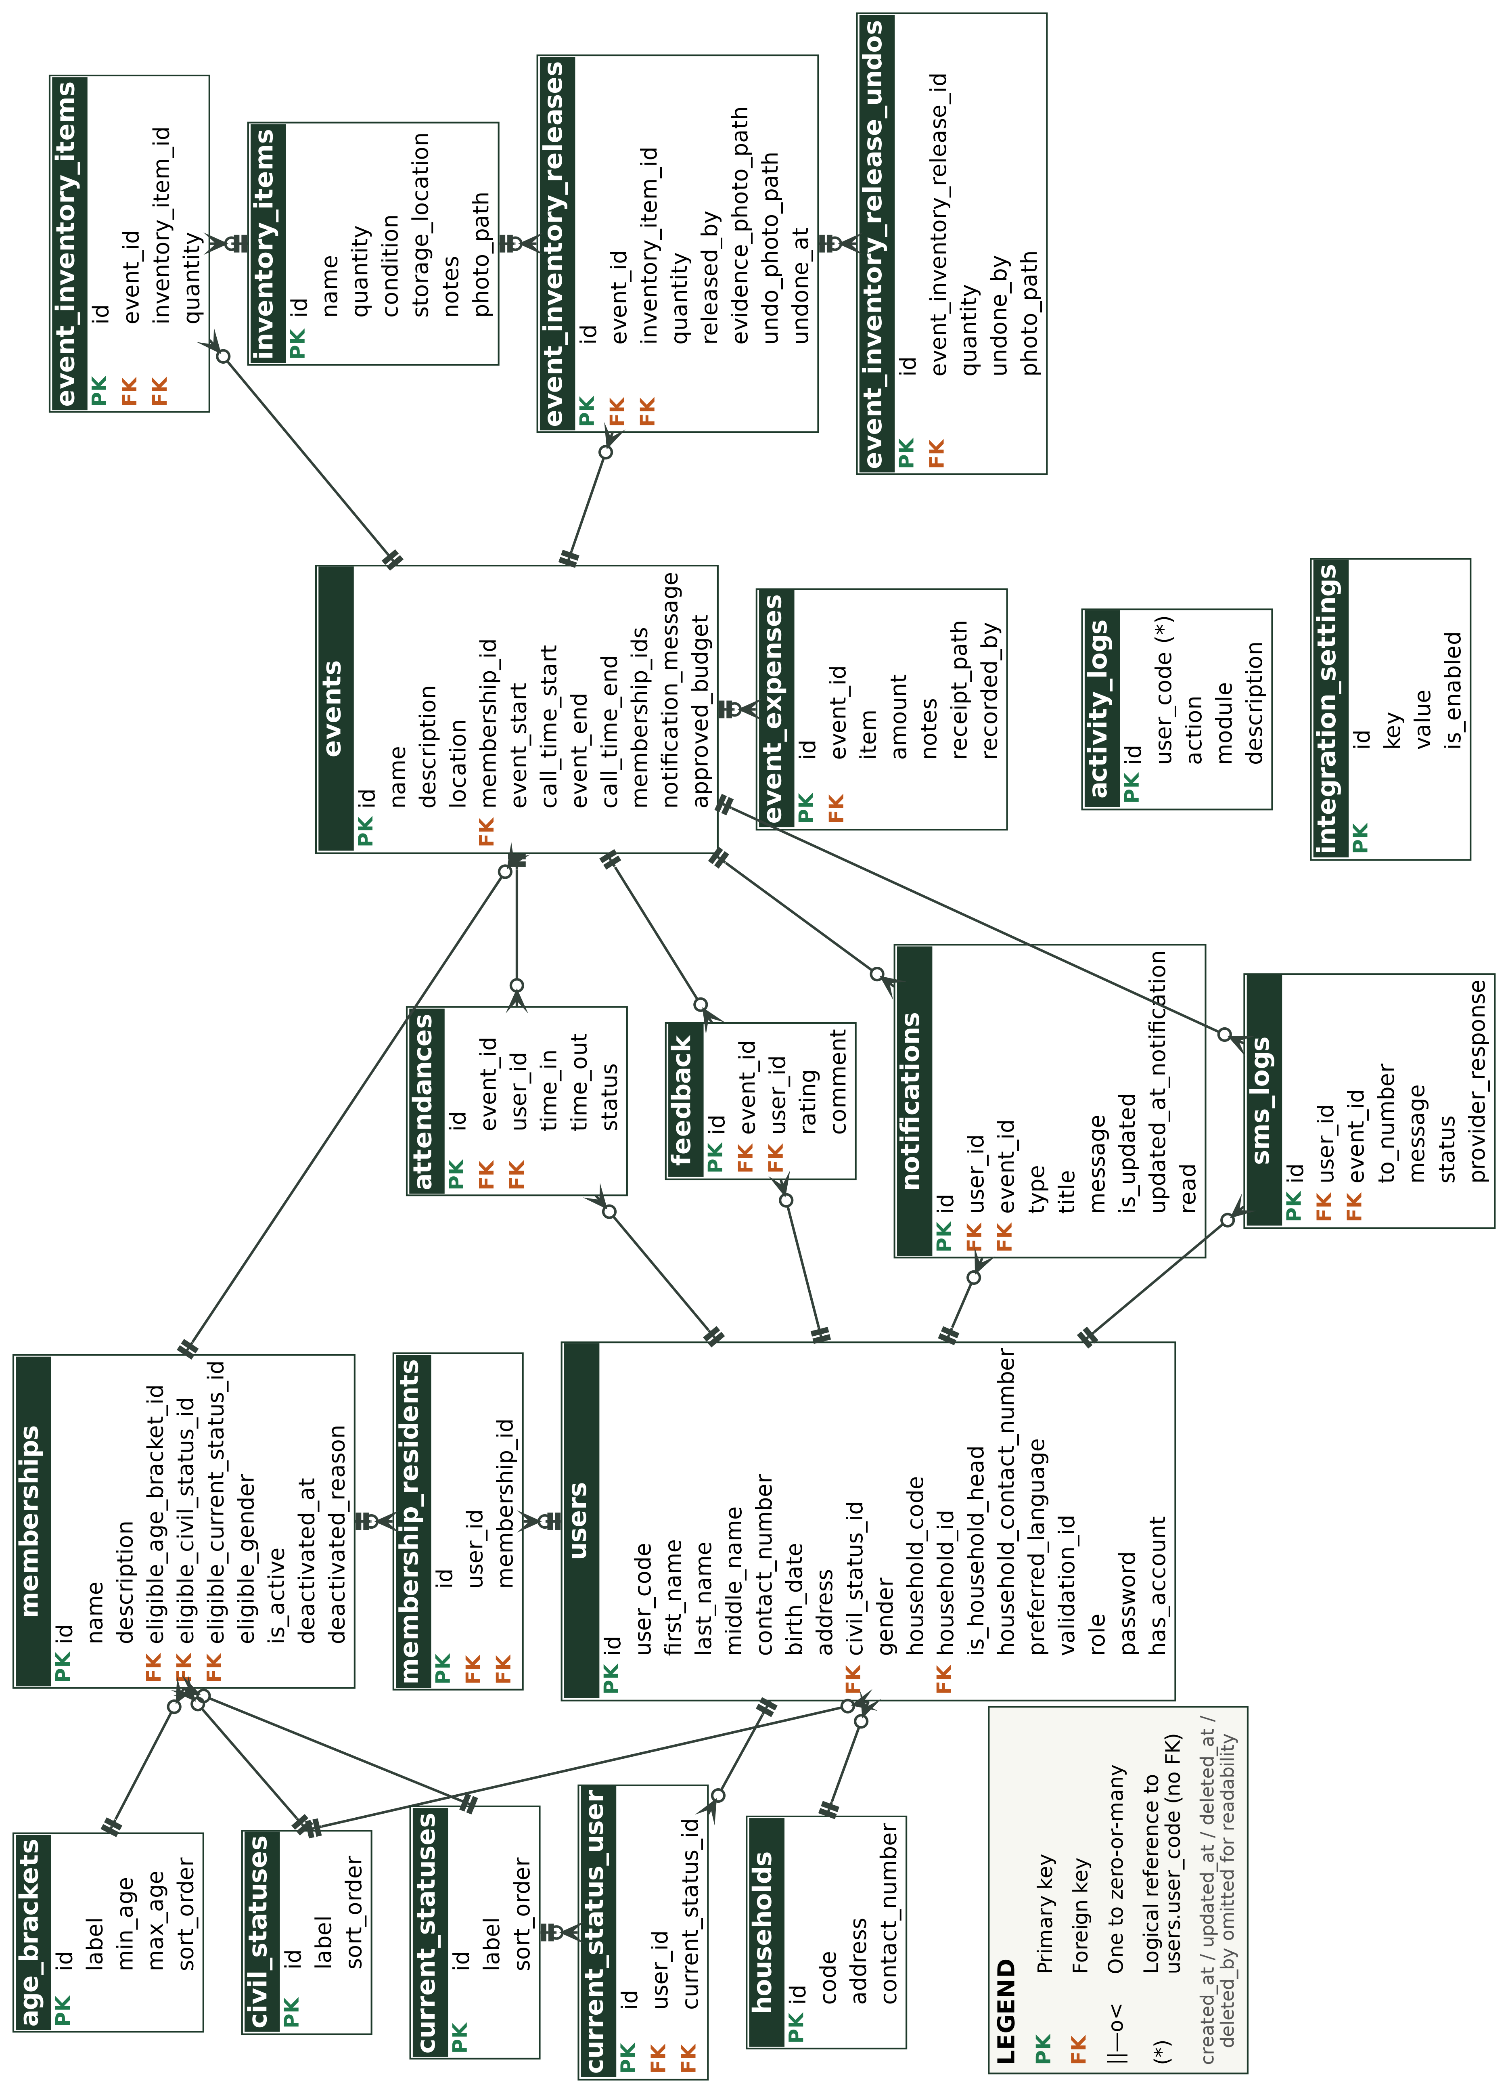
Figure 5. Entity-relationship diagram of the proposed PiaoConnect system.
Every field of every entity in Figure 5 will be documented in a complete data dictionary; Table 6 shows excerpts for the users and events entities as an example of the level of detail to be maintained for each table.
Table 6
Data Dictionary Excerpt — users
Field | Type | Size | Key | Description
id | BIGINT | — | PK | Unique identifier of a user account (resident or staff)
user_code | VARCHAR | 50 | — | Human-readable code assigned to the user (e.g., PR-0006), used in logs and QR payloads
civil_status_id | BIGINT | — | FK | References the user's civil status (lookup)
contact_number | VARCHAR | 15 | — | Mobile number of the person; must be eleven digits beginning with 09 and is used for SMS notifications
household_id | BIGINT | — | FK | References the household the user belongs to
is_household_head | TINYINT | 1 | — | Marks the user as the head of the household, whose number also receives household SMS notices
preferred_language | VARCHAR | 10 | — | Interface language chosen by the user (en, fil, or bis)
password | VARCHAR | 255 | — | Hashed password; set only when has_account is true and validated against the strong-password policy
role | ENUM | — | — | Account type: Staff or Resident

Table 7
Data Dictionary Excerpt — events
Field | Type | Size | Key | Description
id | BIGINT | — | PK | Unique identifier of a barangay event
name | VARCHAR | 255 | — | Short name of the event shown on the events list and notifications
event_start | DATETIME | — | — | Date and time the event begins
call_time_start | DATETIME | — | — | Time attendees are asked to arrive, shown in the notification and used for the attendance window
location | VARCHAR | 100 | — | Venue or place where the event is held
approved_budget | DECIMAL | 10,2 | — | Approved budget amount for the event, compared against recorded expenses
membership_id | BIGINT | — | FK | References the single membership group the event is restricted to, if any (nullable); events restricted to several groups list them in membership_ids
membership_ids | JSON | — | — | List of every membership group the event is restricted to (nullable)
notification_message | TEXT | — | — | Optional custom message sent in notifications and SMS for the event

3.4.3 System Architecture and Interface Design
PiaoConnect follows a three-tier architecture, illustrated in Figure 6. The presentation tier is a responsive single-page web application, built with React and TypeScript and styled with Tailwind CSS, accessible through a desktop or mobile browser and rendered in English, Filipino/Tagalog, or Bisaya according to the user's preference; this is also the tier where a member's QR code is displayed on screen and where barangay staff scan a member's QR code using the device camera during an event. The application tier, built with the Laravel framework, contains the system's business logic — including validating a scanned QR code against the corresponding member record, computing event budgets and inventory updates, sending SMS messages and publishing to Facebook through external APIs, and generating reports — and exposes this logic to the frontend through a REST API. The data tier is a MySQL/MariaDB relational database that stores the resident, membership, attendance, event, budget, and inventory records defined in the data model. Separating the tiers in this way keeps the system maintainable and allows the presentation, logic, and storage layers to be developed, tested, and scaled independently. Event notifications and post-event feedback prompts are generated by the application tier and written directly to the database as they occur; residents see them the next time they open the web application, in an in-app notification center in the presentation tier. The application tier additionally calls two external services — the IPROG SMS gateway for text messages and the Facebook Graph API for page posts — and records every SMS attempt in the sms_logs entity, so that an outage of either service never blocks the core workflow.
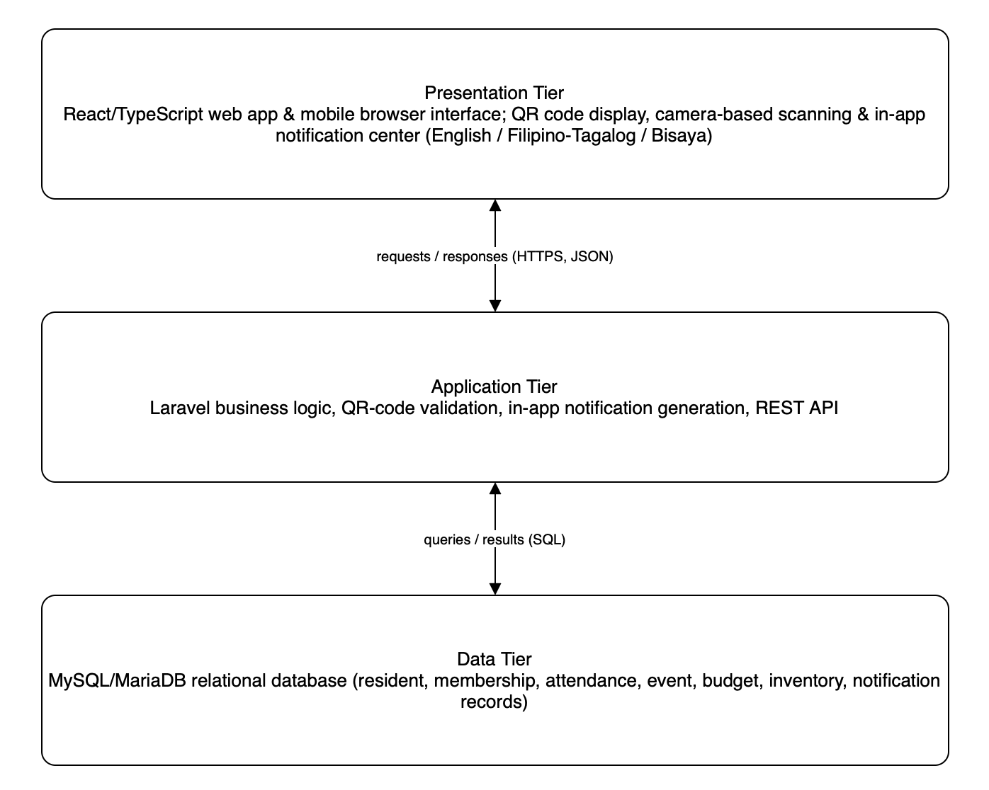
Figure 6. Three-tier architecture of the proposed PiaoConnect system.
The server-side code follows a layered structure, separating presentation concerns from business logic and data access. Table 8 sets out the division.
Table 8
Internal Structure of the Server-Side Solution
Component | Contents | Depends on
Models | Eloquent model classes for each entity (User, Household, Membership, MembershipResident, Event, EventAttendance, Notification, SmsLog, Feedback, EventExpense, InventoryItem, EventInventoryItem, EventInventoryRelease, EventInventoryReleaseUndo, ActivityLog, IntegrationSetting, and the lookup models AgeBracket, CivilStatus, and CurrentStatus), including their relationships, query scopes, and soft-delete behavior | Database (migrations)
Requests and Rules | Form request classes and custom validation rules, such as the StrongPassword rule, that validate and authorize incoming data before it reaches a controller | Models
Services | Business logic classes kept independent of the HTTP layer, including SmsService (IPROG SMS delivery and logging) and FacebookService (Graph API page posting), together with QR-code validation, attendance recording, budget computation, and report generation | Models, Requests
Controllers | HTTP request handlers for each resource (users and residents, households, memberships, eligibility lookups, events, attendance, expenses, inventory, releases, notifications, feedback, archive, activity logs, integrations, and reports), delegating business logic to services and returning JSON responses | Requests, Services, Models
Routes / Middleware | REST route definitions grouped by resource, protected by authentication and rate-limiting middleware (for example, the login route is limited to six attempts per minute); role checks that distinguish barangay staff from resident/member accounts are enforced in the controllers | Controllers
Database (Migrations & Seeders) | Schema migrations, foreign key constraints, and seed data for the MySQL/MariaDB database | Nothing

The user interface was designed for use by barangay staff with limited technical background and by residents on ordinary mobile phones. Wireframes were prepared for the primary screens — staff login and dashboard, resident/member registration, QR code display, attendance scanning, event posting, budget and inventory entry, borrowed-item release and return with photo upload and preview, and the resident-facing event and feedback screens — together with a navigation flow that keeps common staff tasks, such as scanning attendance during an event, to as few steps as possible. The complete wireframes and navigation map will be included in the appendices.

Tools and Technologies
The technologies for PiaoConnect were selected for their fit to the requirements in Table 3 and Table 4, their cost — all of the core components are free or open source — and the ability of the student development team to learn and support them within the project timeline. Table 9 summarizes the selected technology stack.
Table 9
Technology Stack of PiaoConnect
Layer | Technology | Purpose
Frontend | React 19 with TypeScript, Tailwind CSS | Responsive, mobile-friendly user interface for staff and residents
Backend | Laravel 12 (PHP) | Business logic, routing, and REST API endpoints
Database | MySQL / MariaDB | Relational storage for residents, memberships, events, attendance, notifications, budgets, inventory, and logs
QR code generation | qrcode.react | Generates a scannable QR code for each registered resident
QR code scanning | @yudiel/react-qr-scanner | Camera-based scanning of a resident's QR code during events
Build tool | Vite | Frontend bundling and hot-reload development server
Reports and exports | barryvdh/laravel-dompdf, phpoffice/phpword, write-excel-file | Printable PDF and Word reports and Excel exports of attendance, membership, budget, and inventory data
SMS gateway | IPROG SMS API (via SmsService) | Delivers SMS notifications to residents and household heads, with every attempt logged
Social media | Facebook Graph API (via FacebookService) | Publishes posted events to the barangay’s Facebook Page
Version control | Git and GitHub | Source code management and team collaboration

Use Case Narratives
This section presents the complete inventory of use cases for PiaoConnect and a fully-dressed narrative for each, following the format used to specify individual user goals and system responsibilities. Table 10 lists every use case together with its identifier, primary actor, and the functional requirement it satisfies.
Table 10
Use Case Inventory
ID | Use Case | Primary Actor | Requirements
UC-1 | Log In | Resident/Member, Barangay Staff | FR-13
UC-2 | Register Resident and Create Membership Account | Barangay Staff | FR-1, FR-22
UC-3 | Manage Resident Records | Barangay Staff | FR-1
UC-4 | Manage Membership Groups | Barangay Staff | FR-2
UC-5 | Generate Member QR Code | Barangay Staff | FR-3
UC-6 | Scan Attendance | Barangay Staff | FR-4, FR-7
UC-7 | Post Event and Trigger Notifications | Barangay Staff | FR-5, FR-6, FR-18
UC-8 | Record Event Budget and Expenses | Barangay Staff | FR-9
UC-9 | Manage Barangay Inventory | Barangay Staff | FR-10
UC-10 | Generate Printable Reports | Barangay Staff | FR-8
UC-11 | Manage Own Profile | Resident/Member | FR-1, FR-22
UC-12 | Display QR Code | Resident/Member | FR-3
UC-13 | View Attendance History | Resident/Member | FR-7
UC-14 | View Posted Events | Resident/Member | FR-5
UC-15 | Receive Notifications | Resident/Member | FR-6
UC-16 | Submit Post-Event Feedback | Resident/Member | FR-11
UC-17 | Switch Interface Language | Resident/Member, Barangay Staff | FR-12
UC-18 | Log Out | Resident/Member, Barangay Staff | FR-13
UC-19 | Manage Households | Barangay Staff | FR-14
UC-20 | Configure Membership Eligibility Settings | Barangay Staff | FR-15
UC-21 | Archive and Restore Records | Barangay Staff | FR-16
UC-22 | Release and Return Borrowed Inventory Items | Barangay Staff | FR-17
UC-23 | Manage Facebook Page Integration | Barangay Staff | FR-18
UC-24 | View Activity Logs | Barangay Staff | FR-19
UC-25 | Change Password | Resident/Member, Barangay Staff | FR-20, FR-21

Table 11
Use Case 1 Narrative: Log In (UC-1)
Log In (UC-1)
Scope | PiaoConnect: An Integrated Web-Based Membership, Attendance, Event, and Resource Management System for Barangay Piao
Level | User Goal
Goal in Context | Allow a registered resident, member, or barangay staff user to authenticate before accessing the functions of their role.
Primary Actor | Resident/Member, Barangay Staff
Stakeholders | Barangay Piao staff and residents who need assurance that only authorized users can view or change records.
Preconditions | The user already has an account created either by barangay staff (for a resident/member) or by an administrator (for a staff account).
Triggers | The user opens PiaoConnect and selects Log In.
Success Guarantee | The system authenticates the user, opens the dashboard appropriate to their role, and records the login event.
Main Success Scenario
1. The user opens PiaoConnect and selects Log In.
2. The system displays a login form asking for a username or resident ID and a password.
3. The user enters their credentials and submits the form.
4. The system verifies the credentials against the stored, hashed password.
5. The system determines the user's role (Barangay Staff or Resident/Member) and opens the corresponding dashboard.
Extensions
4a. The credentials do not match any account: the system states that the username or password is incorrect and allows another attempt.
4b. The account has been deactivated by an administrator: the system denies access and displays a message directing the user to contact barangay staff.
4c. The user has made more than six login attempts within one minute: the system temporarily rejects further attempts and asks the user to wait before trying again.

Table 12
Use Case 2 Narrative: Register Resident and Create Membership Account (UC-2)
Register Resident and Create Membership Account (UC-2)
Scope | PiaoConnect: An Integrated Web-Based Membership, Attendance, Event, and Resource Management System for Barangay Piao
Level | User Goal
Goal in Context | Allow barangay staff to add a new resident to the system and, where applicable, create the corresponding member account.
Primary Actor | Barangay Staff
Stakeholders | Barangay Piao staff, who need an accurate and searchable roll of residents; residents, whose basic information must be recorded correctly.
Preconditions | The resident is not yet registered in the system.
Triggers | Barangay staff selects Register Resident from the dashboard, typically during in-person registration at the barangay hall.
Success Guarantee | The system creates a resident record and, if a membership account is requested, a linked member account with a unique QR code.
Main Success Scenario
1. Barangay staff selects Register Resident.
2. The system displays a form asking for the resident's name, address (Purok), birth date, contact number, and household information.
3. Staff fills in the fields and indicates whether the resident should also be registered as a member.
4. The system validates the entries, checking that required fields are complete and that the resident is not already on record.
5. The system creates the resident record and, if requested, creates a linked member account with an initial active status.
6. The system generates a unique QR code for the new member account, consistent with UC-5.
Extensions
4a. A required field is empty or a contact number is not an eleven-digit mobile number beginning with 09: the system marks the field and asks staff to correct it.
4b. A resident with matching name and birth date already exists: the system warns staff of the possible duplicate and asks for confirmation before proceeding.

Table 13
Use Case 3 Narrative: Manage Resident Records (UC-3)
Manage Resident Records (UC-3)
Scope | PiaoConnect: An Integrated Web-Based Membership, Attendance, Event, and Resource Management System for Barangay Piao
Level | User Goal
Goal in Context | Allow barangay staff to search, view, and update the stored information of an existing resident.
Primary Actor | Barangay Staff
Stakeholders | Barangay Piao staff, who rely on records staying current; residents, whose information should be corrected promptly when it changes.
Preconditions | The resident is already registered in the system.
Triggers | Barangay staff selects Resident Records from the dashboard and searches for a resident.
Success Guarantee | The requested resident record is displayed, and any changes staff make are saved and time-stamped.
Main Success Scenario
1. Barangay staff selects Resident Records and enters a name, Purok, or resident ID to search.
2. The system returns matching resident records.
3. Staff selects a resident to view the full profile.
4. Staff edits one or more fields, such as address, contact number, or household composition.
5. The system validates the changes and saves the updated record.
Extensions
2a. No resident matches the search terms: the system states that no record was found and offers to register a new resident.
4a. An edited field fails validation: the system marks the field and asks staff to correct it before saving.
4b. Staff sets or resets a resident’s password while editing the record: the system applies the strong-password policy of UC-25 and stores only the hashed value.

Table 14
Use Case 4 Narrative: Manage Membership Groups (UC-4)
Manage Membership Groups (UC-4)
Scope | PiaoConnect: An Integrated Web-Based Membership, Attendance, Event, and Resource Management System for Barangay Piao
Level | User Goal
Goal in Context | Allow barangay staff to create membership groups and assign residents to one or more of them.
Primary Actor | Barangay Staff
Stakeholders | Barangay Piao staff, who organize residents into purok organizations and other groups; members, whose group assignments determine which events and communications apply to them.
Preconditions | Barangay staff is logged in with the appropriate role.
Triggers | Barangay staff selects Membership Groups from the dashboard.
Success Guarantee | The membership group is created, updated, or the member's group assignment is saved.
Main Success Scenario
1. Barangay staff selects Membership Groups.
2. The system displays the list of existing membership types (for example, a Purok organization or the senior citizens' association).
3. Staff selects Add Group and enters a name and description, or selects an existing group to manage its members.
4. Staff searches for and selects a member to add to the group.
5. The system records the assignment through the MemberMembership entity, allowing the same member to belong to more than one group.
Extensions
3a. Staff enters a group name that already exists: the system states that the group exists and asks for a different name.
4a. The selected member is already assigned to the group: the system informs staff and takes no further action.

Table 15
Use Case 5 Narrative: Generate Member QR Code (UC-5)
Generate Member QR Code (UC-5)
Scope | PiaoConnect: An Integrated Web-Based Membership, Attendance, Event, and Resource Management System for Barangay Piao
Level | Subfunction
Goal in Context | Produce a unique, scannable QR code for a member account so that the member can be identified quickly during attendance recording.
Primary Actor | Barangay Staff
Stakeholders | Barangay staff, who need a fast and reliable way to identify members at events; members, who benefit from not having to sign paper attendance sheets.
Preconditions | A member account exists and does not yet have a valid QR code, or an existing code must be reissued.
Triggers | The system reaches the QR-generation step of resident registration (UC-2), or staff selects Reissue QR Code for an existing member.
Success Guarantee | A unique encoded string is generated, stored against the member record, and rendered as a scannable QR code image.
Main Success Scenario
1. The system, or barangay staff acting on a member's behalf, initiates QR code generation for a member account.
2. The system generates a unique encoded string tied to the member's account identifier.
3. The system stores the encoded string in the member record.
4. The system renders the encoded string as a QR code image using the qrcode.react library.
5. The QR code becomes available for the member to view (UC-12) and for staff to scan at events (UC-6).
Extensions
2a. The generated string collides with an existing one: the system regenerates the string until a unique value is produced.
4a. Staff reissues a QR code for a member who lost access to their previous one: the system invalidates the old code before rendering the new one.

Table 16
Use Case 6 Narrative: Scan Attendance (UC-6)
Scan Attendance (UC-6)
Scope | PiaoConnect: An Integrated Web-Based Membership, Attendance, Event, and Resource Management System for Barangay Piao
Level | User Goal
Goal in Context | Allow barangay staff to record a member's attendance at a barangay event by scanning the member's QR code.
Primary Actor | Barangay Staff
Stakeholders | Barangay staff, who need attendance recorded quickly during events with many attendees; members, whose participation should be credited accurately.
Preconditions | The event has already been posted (UC-7), and the member holds a valid QR code (UC-5).
Triggers | Barangay staff selects Scan Attendance for an ongoing event.
Success Guarantee | An Attendance record is created linking the member to the event, with the scan time and method recorded.
Main Success Scenario
1. Barangay staff selects the event and chooses Scan Attendance.
2. The system activates the device camera using the QR scanning library.
3. Staff points the camera at the member's displayed QR code.
4. The system validates the scanned code against the member record and confirms the member is not already marked present for this event.
5. The system creates the Attendance record, storing the scan time and the scanning method used.
6. The system displays a confirmation with the member's name so staff can verify the correct person was scanned.
Extensions
4a. The scanned code does not match any member record: the system rejects the scan and asks staff to try again or search manually.
4b. The member has already been recorded present for this event: the system informs staff and does not create a duplicate record.

Table 17
Use Case 7 Narrative: Post Event and Trigger Notifications (UC-7)
Post Event and Trigger Notifications (UC-7)
Scope | PiaoConnect: An Integrated Web-Based Membership, Attendance, Event, and Resource Management System for Barangay Piao
Level | User Goal
Goal in Context | Allow barangay staff to publish details of an upcoming barangay activity and notify members automatically.
Primary Actor | Barangay Staff
Stakeholders | Barangay staff, who need to communicate schedules efficiently; members, who rely on timely notice of events that concern them.
Preconditions | Barangay staff is logged in with the appropriate role.
Triggers | Barangay staff selects Post Event from the dashboard.
Success Guarantee | The event is stored and visible to members, an in-app notification is generated for each affected member, an SMS is sent or logged for each member with a mobile number, and the event is published to the Facebook Page when that integration is connected.
Main Success Scenario
1. Barangay staff selects Post Event.
2. The system displays a form asking for the event title, date, call time, location, and description, and an optional custom notification message.
3. Staff fills in the fields, optionally restricting the event to one or more membership groups, and submits the form.
4. The system validates the entries and creates the event record.
5. The system generates a Notification record for each member covered by the event and sends an SMS to each member’s mobile number (and the household head’s) through the SMS gateway, recording every attempt in the SMS log.
6. If the Facebook Page integration is connected (UC-23), the system also publishes the event to the barangay’s Facebook Page.
7. Members see the new notification the next time they open PiaoConnect (UC-15) and can view the event on their events screen (UC-14).
Extensions
3a. A required field is empty or the event date is in the past: the system marks the field and asks staff to correct it.
5a. No members belong to the specified membership group: the system posts the event but records that no notifications were generated.
5b. The SMS gateway is not configured or rejects a message: the system records the message as simulated or failed in the SMS log and continues, so that posting the event is never blocked.

Table 18
Use Case 8 Narrative: Record Event Budget and Expenses (UC-8)
Record Event Budget and Expenses (UC-8)
Scope | PiaoConnect: An Integrated Web-Based Membership, Attendance, Event, and Resource Management System for Barangay Piao
Level | User Goal
Goal in Context | Allow barangay staff to record the approved budget for an event and log the actual expenses incurred.
Primary Actor | Barangay Staff
Stakeholders | Barangay staff, who are accountable for how event funds are spent; barangay officials, who review budget-versus-actual figures.
Preconditions | The event has already been posted (UC-7).
Triggers | Barangay staff selects Manage Budget for a specific event.
Success Guarantee | The approved budget is recorded, and each itemized expense is stored as an EventExpense linked to the event.
Main Success Scenario
1. Barangay staff selects an event and chooses Manage Budget.
2. The system displays a form asking for the approved budget amount.
3. Staff enters the approved budget and saves it.
4. Staff selects Add Expense and enters a description and amount for each item purchased or paid for, and attaches the receipt as an image or PDF, which can be previewed before it is submitted.
5. The system stores each entry as an EventExpense record linked to the event and updates the running total of actual expenses.
Extensions
3a. The entered budget is negative or not a number: the system rejects the value and asks for a valid amount.
5a. The running total of expenses exceeds the approved budget: the system still saves the entry but flags the event as over budget.
4a. Staff submits an expense without a receipt: the system rejects it and asks for the receipt file.

Table 19
Use Case 9 Narrative: Manage Barangay Inventory (UC-9)
Manage Barangay Inventory (UC-9)
Scope | PiaoConnect: An Integrated Web-Based Membership, Attendance, Event, and Resource Management System for Barangay Piao
Level | User Goal
Goal in Context | Allow barangay staff to record and monitor barangay-owned items, including their quantity, condition, and storage location.
Primary Actor | Barangay Staff
Stakeholders | Barangay staff, who are responsible for barangay property and need to know what is available and where it is kept.
Preconditions | Barangay staff is logged in with the appropriate role.
Triggers | Barangay staff selects Inventory from the dashboard.
Success Guarantee | The InventoryItem record is created or updated to reflect the current quantity, condition, and location.
Main Success Scenario
1. Barangay staff selects Inventory.
2. The system displays the current list of barangay-owned items.
3. Staff selects Add Item, or selects an existing item to update it.
4. Staff enters or edits the item name, quantity, condition, and storage location, and may attach a photo of the item, which can be previewed before it is saved.
5. The system validates the entries and saves the InventoryItem record.
Extensions
4a. The quantity entered is negative: the system rejects the value and asks for a valid quantity.
5a. The item was previously marked as disposed or lost: the system asks staff to confirm before reactivating it.

Table 20
Use Case 10 Narrative: Generate Printable Reports (UC-10)
Generate Printable Reports (UC-10)
Scope | PiaoConnect: An Integrated Web-Based Membership, Attendance, Event, and Resource Management System for Barangay Piao
Level | User Goal
Goal in Context | Allow barangay staff to generate a printable report summarizing attendance, membership, budget, or inventory records.
Primary Actor | Barangay Staff
Stakeholders | Barangay staff and officials, who need summarized records for meetings, audits, and submissions to higher offices.
Preconditions | The underlying attendance, membership, budget, or inventory records already exist.
Triggers | Barangay staff selects Generate Report from the dashboard.
Success Guarantee | The system produces a formatted, printable report reflecting the requested records and date range.
Main Success Scenario
1. Barangay staff selects Generate Report.
2. The system asks staff to choose a report type (attendance, membership, budget, or inventory) and a date range or event.
3. Staff confirms the selection.
4. The system compiles the relevant records into a formatted report.
5. The system displays the report and offers options to print or save it as a PDF.
Extensions
4a. No records exist for the selected type and range: the system states that no data is available for the report.

Table 21
Use Case 11 Narrative: Manage Own Profile (UC-11)
Manage Own Profile (UC-11)
Scope | PiaoConnect: An Integrated Web-Based Membership, Attendance, Event, and Resource Management System for Barangay Piao
Level | User Goal
Goal in Context | Allow a resident or member to view and update their own profile information.
Primary Actor | Resident/Member
Stakeholders | Residents and members, who want their contact information kept current without visiting the barangay hall for minor updates.
Preconditions | The user is logged in as a resident or member.
Triggers | The user selects My Profile from the dashboard.
Success Guarantee | The system saves the updated profile information to the resident or member record.
Main Success Scenario
1. The user selects My Profile.
2. The system displays the user's current profile information.
3. The user edits fields such as contact number or preferred interface language.
4. The system validates the entries and saves the changes.
Extensions
3a. An edited field fails validation, such as a contact number that is not an eleven-digit mobile number beginning with 09: the system marks the field and asks the user to correct it.
3b. The user wishes to change their password: the user follows Change Password (UC-25).

Table 22
Use Case 12 Narrative: Display QR Code (UC-12)
Display QR Code (UC-12)
Scope | PiaoConnect: An Integrated Web-Based Membership, Attendance, Event, and Resource Management System for Barangay Piao
Level | User Goal
Goal in Context | Allow a member to display their own QR code on their device so that barangay staff can scan it during an event.
Primary Actor | Resident/Member
Stakeholders | Members, who need quick, reliable access to their QR code at events.
Preconditions | The member's account already has a QR code generated (UC-5).
Triggers | The member selects My QR Code from the dashboard.
Success Guarantee | The member's QR code is rendered clearly on screen at a size that can be scanned by barangay staff.
Main Success Scenario
1. The member selects My QR Code.
2. The system retrieves the stored, encoded string for the member's account.
3. The system renders the QR code image on screen at a size suitable for scanning.
Extensions
2a. The member's account has no QR code on record: the system states that a code has not yet been issued and directs the member to barangay staff.

Table 23
Use Case 13 Narrative: View Attendance History (UC-13)
View Attendance History (UC-13)
Scope | PiaoConnect: An Integrated Web-Based Membership, Attendance, Event, and Resource Management System for Barangay Piao
Level | User Goal
Goal in Context | Allow a member to review the events they have attended and their recorded attendance times.
Primary Actor | Resident/Member
Stakeholders | Members, who want to confirm that their participation has been recorded correctly.
Preconditions | The member has attended at least one event, or is checking that no attendance has yet been recorded.
Triggers | The member selects My Attendance from the dashboard.
Success Guarantee | The system displays a list of the member's recorded attendance, most recent first.
Main Success Scenario
1. The member selects My Attendance.
2. The system retrieves the Attendance records linked to the member's account.
3. The system displays each attended event with its date and the recorded scan time.
Extensions
2a. No attendance records exist for the member: the system states that no attendance has been recorded yet.

Table 24
Use Case 14 Narrative: View Posted Events (UC-14)
View Posted Events (UC-14)
Scope | PiaoConnect: An Integrated Web-Based Membership, Attendance, Event, and Resource Management System for Barangay Piao
Level | User Goal
Goal in Context | Allow a resident or member to browse upcoming and past barangay events.
Primary Actor | Resident/Member
Stakeholders | Residents and members, who want to know what activities are scheduled and whether they concern their membership group.
Preconditions | At least one event has been posted (UC-7).
Triggers | The user selects Events from the dashboard.
Success Guarantee | The system displays the events applicable to the user, in chronological order.
Main Success Scenario
1. The user selects Events.
2. The system retrieves events that are either open to all residents or restricted to a membership group the user belongs to.
3. The system displays the events with their date, time, location, and description.
4. The user selects an event to view its full details.
Extensions
2a. No events are currently posted: the system states that there are no events to display.

Table 25
Use Case 15 Narrative: Receive Notifications (UC-15)
Receive Notifications (UC-15)
Scope | PiaoConnect: An Integrated Web-Based Membership, Attendance, Event, and Resource Management System for Barangay Piao
Level | User Goal
Goal in Context | Allow a resident or member to view in-app notifications generated by the system, such as new events or feedback requests.
Primary Actor | Resident/Member
Stakeholders | Residents and members, who need a single place to see announcements without relying on external SMS or email.
Preconditions | At least one notification has been generated for the user (for example, through UC-7 or UC-16).
Triggers | The user selects the notification icon from the dashboard.
Success Guarantee | The system displays the user's notifications and marks viewed notifications as read.
Main Success Scenario
1. The user selects the notification icon.
2. The system retrieves the Notification records linked to the user's account.
3. The system displays each notification with its type and the event or item it refers to.
4. The user selects a notification to open the related event or feedback prompt.
5. The system marks the opened notification as read.
Extensions
2a. No notifications exist for the user: the system states that there are no new notifications.

Table 26
Use Case 16 Narrative: Submit Post-Event Feedback (UC-16)
Submit Post-Event Feedback (UC-16)
Scope | PiaoConnect: An Integrated Web-Based Membership, Attendance, Event, and Resource Management System for Barangay Piao
Level | User Goal
Goal in Context | Allow a member to rate and comment on an event they attended, in response to an automated feedback prompt.
Primary Actor | Resident/Member
Stakeholders | Members, whose opinions help barangay staff improve future events; barangay staff, who use the feedback to plan.
Preconditions | The member attended the event, and the system has generated a post-event feedback notification (FR-11).
Triggers | The member opens the feedback notification for an attended event.
Success Guarantee | The system stores the member's rating and comment as a Feedback record linked to the event.
Main Success Scenario
1. The member opens the feedback notification for an attended event.
2. The system displays a short survey asking for a rating and an optional comment.
3. The member submits the rating and comment.
4. The system validates the submission and stores it as a Feedback record linked to the event and the member.
5. The system marks the feedback prompt as completed so it is not shown again for that event.
Extensions
3a. The member submits the form without selecting a rating: the system asks for a rating before accepting the submission.

Table 27
Use Case 17 Narrative: Switch Interface Language (UC-17)
Switch Interface Language (UC-17)
Scope | PiaoConnect: An Integrated Web-Based Membership, Attendance, Event, and Resource Management System for Barangay Piao
Level | User Goal
Goal in Context | Allow a resident, member, or barangay staff user to change the language the interface is displayed in.
Primary Actor | Resident/Member, Barangay Staff
Stakeholders | Residents, members, and staff who are more comfortable using the system in Filipino/Tagalog, Bisaya, or English.
Preconditions | The user is logged in, or is viewing a public screen that offers a language selector.
Triggers | The user selects the language option from the navigation bar.
Success Guarantee | The interface text is re-rendered in the selected language, and the preference is saved for the user's future sessions.
Main Success Scenario
1. The user selects the language option from the navigation bar.
2. The system displays the available languages: Filipino/Tagalog, Bisaya, and English.
3. The user selects a language.
4. The system re-renders the current screen in the selected language.
5. The system saves the selected language as the user's preference for future sessions.
Extensions
5a. The user is not logged in: the system applies the selected language for the current session only, without saving a preference.
Table 28
Use Case 18 Narrative: Log Out (UC-18)
Log Out (UC-18)
Scope | PiaoConnect: An Integrated Web-Based Membership, Attendance, Event, and Resource Management System for Barangay Piao
Level | User Goal
Goal in Context | Allow a resident/member or barangay staff user to end their authenticated session so the account cannot be used by anyone else on that device.
Primary Actor | Resident/Member, Barangay Staff
Stakeholders | Residents, members, and staff who share devices or use shared computers at the barangay hall and need assurance that ending a session actually revokes access.
Preconditions | The user is currently logged in (UC-1).
Triggers | The user selects Log Out from the navigation menu.
Success Guarantee | The system invalidates the current session and returns the user to the Log In screen.
Main Success Scenario
1. The user selects Log Out from the navigation menu.
2. The system invalidates the current authentication session.
3. The system redirects the user to the Log In screen (UC-1).
Extensions
2a. The session has already expired when Log Out is selected: the system discards any remaining session data and displays the Log In screen without error.
Table 29
Use Case 19 Narrative: Manage Households (UC-19)
Manage Households (UC-19)
Scope | PiaoConnect: An Integrated Web-Based Membership, Attendance, Event, and Resource Management System for Barangay Piao
Level | User Goal
Goal in Context | Allow barangay staff to group resident records that share a household into a single household unit and designate one member as household head.
Primary Actor | Barangay Staff
Stakeholders | Barangay staff, who need to reach a household through its head member and understand which residents live together.
Preconditions | Barangay staff is logged in with the appropriate role.
Triggers | Barangay staff selects Households from the dashboard.
Success Guarantee | The household record is created or updated and every linked resident's household reference and head flag correctly reflect the change.
Main Success Scenario
1. Barangay staff selects Households.
2. The system displays the current list of households and their member counts.
3. Staff selects Add Household, or selects an existing household to update it.
4. Staff enters the household's address and contact number and adds or removes member residents.
5. Staff optionally designates one member as household head.
6. The system saves the household record and updates each affected resident's household link.
Extensions
4a. A resident added to the household is already the head of a different household: the system clears that resident's previous head flag before linking them to the new household, so a resident is never head of two households at once.
5a. Staff removes the current household head without naming a replacement: the system allows the change but leaves the household without a head until staff assigns a new one.
Table 30
Use Case 20 Narrative: Configure Membership Eligibility Settings (UC-20)
Configure Membership Eligibility Settings (UC-20)
Scope | PiaoConnect: An Integrated Web-Based Membership, Attendance, Event, and Resource Management System for Barangay Piao
Level | User Goal
Goal in Context | Allow barangay staff to maintain the age bracket, civil status, and current status lookup values that determine who is eligible for a membership group, extending the original senior-citizen example to groups such as youth or solo parents.
Primary Actor | Barangay Staff
Stakeholders | Barangay staff, who define membership eligibility rules and need the underlying lookup values to stay accurate and organized.
Preconditions | Barangay staff is logged in with the appropriate role.
Triggers | Barangay staff selects Profiling Settings from the dashboard.
Success Guarantee | The lookup value is created, updated, or archived, and is immediately available (or unavailable) when staff define a membership's eligibility rule.
Main Success Scenario
1. Barangay staff selects Profiling Settings.
2. The system displays the current Age Brackets, Civil Statuses, and Current Statuses.
3. Staff adds a new lookup value, or edits or archives an existing one.
4. The system validates the entry (for example, that an age bracket's minimum is below its maximum) and saves the change.
5. The updated lookup value becomes available the next time staff define or edit a membership's eligibility rule.
Extensions
3a. Staff attempts to archive a lookup value that an active membership's eligibility rule still references: the system warns staff that doing so would leave that membership unable to match any resident.
Table 31
Use Case 21 Narrative: Archive and Restore Records (UC-21)
Archive and Restore Records (UC-21)
Scope | PiaoConnect: An Integrated Web-Based Membership, Attendance, Event, and Resource Management System for Barangay Piao
Level | User Goal
Goal in Context | Allow barangay staff to reversibly remove records they no longer need active -- residents, events, memberships, and inventory items among them -- and restore or permanently delete them later.
Primary Actor | Barangay Staff
Stakeholders | Barangay staff, who need to keep active lists uncluttered without permanently losing a record by mistake.
Preconditions | Barangay staff is logged in with the appropriate role.
Triggers | Barangay staff selects Delete or Archive on a record, or opens the Archive page.
Success Guarantee | The record is moved to (or back out of) the archive, or permanently removed, and every affected list reflects the change immediately.
Main Success Scenario
1. Barangay staff selects Delete or Archive on a resident, event, membership, or inventory record.
2. The system marks the record as archived and removes it from the active list, recording who archived it.
3. Staff opens the Archive page to review archived records across modules, with filtering by type.
4. Staff selects Restore on an archived record, or Force Delete to remove it permanently.
5. The system restores the record to active status, or permanently deletes it and its archive entry.
Extensions
1a. The record is still referenced by an active dependent record (for example, an inventory item currently borrowed for an event, or a membership with residents still assigned to it): the system blocks the archive action and explains why.
4a. Staff selects Force Delete: the system asks for confirmation, since a permanent delete cannot be undone.
Table 32
Use Case 22 Narrative: Release and Return Borrowed Inventory Items (UC-22)
Release and Return Borrowed Inventory Items (UC-22)
Scope | PiaoConnect: An Integrated Web-Based Membership, Attendance, Event, and Resource Management System for Barangay Piao
Level | User Goal
Goal in Context | Allow barangay staff to record the return of barangay equipment borrowed for an event, in the exact quantity actually returned, and to correct a release recorded in error.
Primary Actor | Barangay Staff
Stakeholders | Barangay staff, who are accountable for barangay property and need inventory counts to reflect what has actually been returned, not just what was originally borrowed.
Preconditions | The event has outstanding borrowed inventory items that have not yet been fully released back to stock (UC-9).
Triggers | Barangay staff opens the Returns view, or selects Release Items on an event with overdue borrows.
Success Guarantee | The released quantity is restocked into inventory, the event’s outstanding-borrow balance is reduced by the same amount, an evidence photo is stored with the release, and the release is recorded in the recently-released history.
Main Success Scenario
1. Barangay staff opens the Returns view, which lists events with outstanding borrowed items.
2. The system displays each such event together with how many of each item are still out.
3. Staff selects an event and opens Release Items.
4. Staff selects which items to release (checked by default) and adjusts the quantity being returned for each, up to the amount still outstanding.
5. Staff attaches a photo as evidence of the return, previews it, and confirms Release Selected.
6. The system deducts the released quantity from the event's outstanding borrow, restocks it into inventory, and adds an entry to the Recently Released history.
7. If a release was recorded in error, staff selects Undo on the corresponding entry, specifies how much of it to undo, and attaches a photo supporting the correction.
8. The system records the undo in the release’s undo history, reverses that quantity back out of inventory and off the release record, and marks the release fully undone once its remaining quantity reaches zero.
Extensions
4a. An item's remaining outstanding quantity is exactly one: no quantity selector is shown and the single unit is released directly.
6a. The release fails for one of several selected items (for example, a concurrent update elsewhere): the system still applies the releases that succeeded and reports which item failed, so staff can retry only that one.
8a. The requested undo quantity exceeds what was actually released: the system clamps the undo to the released quantity rather than over-crediting inventory.
5a. No evidence photo is attached: the system rejects the release (or the undo) and asks staff to attach a photo.
Table 33
Use Case 23 Narrative: Manage Facebook Page Integration (UC-23)
Manage Facebook Page Integration (UC-23)
Scope | PiaoConnect: An Integrated Web-Based Membership, Attendance, Event, and Resource Management System for Barangay Piao
Level | User Goal
Goal in Context | Allow barangay staff to connect the barangay's official Facebook Page to PiaoConnect so that posted events can also be published publicly, and to disconnect it when no longer wanted.
Primary Actor | Barangay Staff
Stakeholders | Barangay staff, who want posted events to reach residents who follow the barangay's Facebook Page; barangay officials, who are accountable for what is posted under the barangay's name.
Preconditions | Barangay staff is logged in with the appropriate role and has access to the barangay's Facebook Page credentials.
Triggers | Barangay staff opens Integrations and selects Facebook.
Success Guarantee | Barangay events chosen for public posting appear on the connected Facebook Page, and staff can verify at any time whether the connection is active.
Main Success Scenario
1. Barangay staff opens the Facebook integration settings.
2. The system shows the current connection status.
3. Staff supplies the barangay Facebook Page's access token and connects it.
4. The system verifies the token and stores the connection.
5. When staff subsequently post a barangay event (UC-7), the system also publishes it to the connected Facebook Page.
6. Staff may disconnect the integration at any time.
Extensions
3a. The supplied access token is invalid or expired: the system rejects the connection attempt and reports the error rather than storing a broken token.
5a. Publishing to Facebook fails at post time (for example, a revoked token): the system still creates the event and its in-app notifications, and records the publishing failure without blocking the event from being posted.
Table 34
Use Case 24 Narrative: View Activity Logs (UC-24)
View Activity Logs (UC-24)
Scope | PiaoConnect: An Integrated Web-Based Membership, Attendance, Event, and Resource Management System for Barangay Piao
Level | User Goal
Goal in Context | Give barangay staff a searchable, chronological record of significant actions taken in the system -- creating, archiving, and restoring records; releasing inventory; recording expenses; and similar actions -- for accountability and troubleshooting.
Primary Actor | Barangay Staff
Stakeholders | Barangay staff and officials, who need to know who made a given change and when, especially when reviewing a disputed or unexpected record.
Preconditions | Barangay staff is logged in with the appropriate role.
Triggers | Barangay staff selects Activity Logs from the dashboard.
Success Guarantee | Staff can locate the specific staff action they are looking for, narrowed by date, module, or keyword.
Main Success Scenario
1. Barangay staff selects Activity Logs.
2. The system displays the most recent entries across all modules, each showing the staff member, the action taken, the affected module, and a description.
3. Staff filters the list by date or module, or searches by keyword such as a resident's name or staff user code.
4. The system narrows the list to matching entries.
5. Staff may open Today's Activity to review only the current day's actions.
Extensions
1a. The requesting account is a resident rather than staff: the system denies access to the activity log.
3a. The search matches no entries: the system displays a clear no-results message rather than an empty table.
Table 35
Use Case 25 Narrative: Change Password (UC-25)
Change Password (UC-25)
Scope | PiaoConnect: An Integrated Web-Based Membership, Attendance, Event, and Resource Management System for Barangay Piao
Level | User Goal
Goal in Context | Allow a logged-in resident, member, or barangay staff user to replace their own password with a new one that satisfies the system’s strong-password policy.
Primary Actor | Resident/Member, Barangay Staff
Stakeholders | Residents, members, and barangay staff, who need their accounts protected from guessing and misuse, and Barangay Piao, which is responsible for safeguarding personal data under the Data Privacy Act of 2012.
Preconditions | The user is logged in (UC-1).
Triggers | The user selects Change Password from their profile or account menu.
Success Guarantee | The new password is validated, stored only as a hash, and used for the user’s next login; the previous password no longer works.
Main Success Scenario
1. The user selects Change Password.
2. The system displays a form with a New Password field and a Confirm Password field, each with a show/hide toggle.
3. As the user types, the system displays a live checklist of the policy rules (8 to 64 characters, an uppercase letter, a lowercase letter, a digit, a special character, and no spaces) showing which are met.
4. The user enters and confirms the new password and submits the form.
5. The system validates the password against the policy on the server and checks that both entries match.
6. The system stores the new password as a hash and confirms that the password was changed.
Extensions
5a. The new password breaks one or more policy rules: the system rejects it, lists the rules that failed, and keeps the existing password.
5b. The two entries do not match: the system rejects the change and asks the user to re-enter the confirmation.
6a. Staff changes a resident’s password while editing that resident’s record (UC-3): the same policy is applied and only the hashed value is stored.

Testing and Evaluation Plan
The system will be tested and evaluated during the implementation phase in Capstone 2. Testing will proceed from unit testing of individual modules — such as QR code generation and validation, attendance recording, budget computation, SMS delivery logging, and password-policy validation — to integration testing across modules, and finally to user acceptance testing with Barangay Piao staff and a sample of resident volunteers. Consistent with the evaluation criteria stated in the objectives of this study, the quality of PiaoConnect will be assessed against five characteristics of the ISO/IEC 25010 software quality model [14]: functionality, usability, reliability, security, and efficiency — the same evaluation approach used in several of the reviewed related systems [7], [8], [12]. A structured evaluation instrument based on these five characteristics will be administered to barangay staff and resident respondents using a Likert-type scale; their ratings will be summarized and interpreted to determine whether PiaoConnect meets its acceptance criteria before it is turned over to Barangay Piao.

References
[1] R. P. Bringula, M. A. D. Vale, J. A. Napolis, F. P. Oliva, and D. J. T. De La Serna, “E-Barangay: A framework for a web-based system for local communities and its usability,” Procedia Computer Science, vol. 197, pp. 573–580, 2022.

[2] J. T. Aliling, B. B. Santa Ana, and K. T. Soberano, “Digitalizing governance: A transformation on the processes of one community in the Philippines,” Zenodo, 2025.

[3] D. J. B. Agripa and S. F. Astillero, “Development of employee attendance and management system using quick response (QR) code in Sorsogon State University,” European Journal of Education Studies, vol. 9, no. 7, pp. 345–361, 2022.

[4] S. Raut, P. Bhure, P. Bariye, A. Nandeshwar, and J. Adhikari, “QR code-based attendance system,” International Research Journal of Modernization in Engineering Technology and Science, vol. 5, no. 6, pp. 425–429, Jun. 2023.

[5] S. Pati, S. Bhanja, A. Majumder, S. Sahu, S. Banerjee, and G. Sen, “A novel QR code-based smart attendance tracking system,” in Proc. 2023 7th Int. Conf. Electronics, Materials Engineering and Nano-Technology (IEMENTech), 2023.

[6] F. Y. Chowdhury, “Implementation of attendance management system utilizing fingerprint, QR code, and GPS technology in educational institutions,” International Journal of Scientific Research (IJSR), vol. 12, no. 9, pp. 2016–2019, 2023.

[7] U. M. Melendres and K. M. Aranda, “Development and evaluation of a web-based resident information management system,” Journal of Computer Software Programming, vol. 1, no. 1, pp. 14–22, 2024.

[8] M. J. G. Ballaran, M. J. M. Donaire, R. M. Singzon, S. M. Naz, D. V. Tanael, and C. J. Centeno, “Development and evaluation of web-based barangay profiling and issuance system using regression analysis,” World Journal of Advanced Research and Review, vol. 20, no. 3, pp. 60–72, 2023.

[9] J. V. Enaño, K. P. Natividad, D. R. Pantoja, F. C. D. Ebi, J. V. Bautista, and D. Cura, “BarangayConnect: A web-based information portal for resident data, administrative services, and community records using data analytics and linear regression algorithms,” International Journal of Research and Innovation in Social Science, vol. 9, no. 10, pp. 1485–1497, Nov. 2025.

[10] F. M. Reyes, M. A. Abdulgani, M. F. Aliuden, J. M. Mantikayan, T. S. Guiamalon, S. G. Dilna, H. A. Mohamad, and S. Z. D. Nawal, “Event management system with SMS notification for Mindanao People's Care Foundation, Inc.,” Psychology and Education: Multidisciplinary Journal, vol. 3, no. 7, pp. 600–609, 2022.

[11] G. P. Concepcion, “Language choice in Philippine government websites: Sociolinguistic issues and implications,” SUVANNABHUMI, vol. 13, no. 1, pp. 35–64, Jan. 2021.

[12] B. A. Anggoto, C. G. Gonzaga, T. J. S. Varona, and P. C. Encarnacion, “Kabataan-Konek: A barangay web-based youth information management system with data analytics,” International Journal of Science and Applied Information Technology, vol. 14, no. 3, pp. 27–30, May–Jun. 2025.

[13] I. Sommerville, Software Engineering, 10th ed. Boston, MA, USA: Pearson, 2016.

[14] International Organization for Standardization, ISO/IEC 25010:2011 — Systems and Software Engineering — Systems and Software Quality Requirements and Evaluation (SQuaRE) — System and Software Quality Models, ISO/IEC, Geneva, Switzerland, 2011.

[15] Congress of the Philippines, Data Privacy Act of 2012, Republic Act No. 10173. Manila, Philippines, 2012.

